EVALUATION OF PROPERTIES OF NON-STOICHIOMETRIC ALUMINA MAGNESIA SPINEL USING THIOUREA AS FUEL BY VARYING SOAKING TIME
Sathi Banerjee 1, Soumya Mukherjee 2*, and Srinath Ranjan Ghosh 1
¹ Department of Metallurgical & Materials Engineering, Jadavpur University, India
^{2*} Department of Metallurgical Engineering, Kazi Nazrul University, India
ABSTRACT: The present article reports a simple and cost-effective process to prepare the crystalline MgAl₂O₄ spinel using a non-stoichiometric amount of magnesium nitrate, aluminum nitrate by solution combustion route. Thiourea was used as a fuel and reducing agent while soaking was carried at 1000ºC with different soaking periods. After slow drying of mixed solutions at 80ºC for 4-5 h, a gel was formed and got characterized by DTA/TGA (Differential Thermal Analysis and Thermal Gravimetric Analysis) to observe the effect of temperature variation and identify the range of temperature where crystalline nature of the powder was noted. A powder sample was prepared from the gel after annealing at 1000ºC followed by soaking for 4 h, 5 h, and 6 h to compare the variation of particle size with respect to time. The calcined powders were characterized by XRD (X-ray powder diffraction) to determine the phases and crystal planes present in the sample. FT-IR (Fourier-transform infrared spectroscopy) was used to study the types of metal oxide or metal-metal bond present in the sample along with M-O coordination studies. FESEM (Field emission scanning electron microscopy) was used to observe the morphological structure of the sample. EDAX (Energy Dispersive X-Ray Analysis) was used to observe the percentage of each element present in the sample. Bulk densities were estimated from 2.4156 g/cm³ to 2.8571 g/cm³ and the rapid increase in apparent porosity of samples 7.4289%, 10.3630% and 32.51% for 4 hours 5 hours and 6 hours respectively were also noted. The average crystal size of spinel particles was noted to be about 48nm, 36 nm and 47 nm respectively. It had been observed that the average crystal size of spinel particles was about 48 nm, 36 nm and 47 nm respectively. Finally, the hardness of spinel was evaluated by Vicker Hardness test and evaluated to be10.52 GPa (1073 HV), 4.087 GPa (416.7HV) and 5.079 GPa (517.9HV).
Keywords: Magnesium Aluminate; Phase analysis; Morphology; M-O co-ordinations; Vicker hardness.
تقييم خصائص ألياف الألمنيوم المغنيسي غير المتكافئ باستخدام مادة الثيوريا كوقود عن طريق تغيير وقت النقع
ساثي بنجري, سوميا مخرجي*, و سريناث رانجان جوش
الملخص: تناقش هذه الورقة العلمية عملية بسيطة وفعالة من حيث التكلفة لإعداد الاسبنيل MgAl₂O₄ البلوري باستخدام كمية غير متكافئة من نترات المغنيسيوم ونترات الألومنيوم بطريقة احتراق المحلول. واستخدمت الثيوريا كوقود وعامل خفض في حين نقعت في درجة حرارة 1000سيليزية مع فترات مختلفة من النقع. بعد التجفيف البطيء للمحاليل المختلطة في درجة حرارة 80 سيليزية لمدة 4-5 ساعة ، تشكل هلام بواسطة DTA/TGA (التحليل الحراري التفاضلي والتحليل الحراري لقياس الحرارة) لمراقبة تأثير التباين في درجات الحرارة وتحديد مدى درجة الحرارة حيث لوحظ الطبيعة البلورية للمسحوق. وأعدت عينة من المسحوق من الهلام بعد تلدينها في درجة حرارة 1000 سيليزية ثم نقعها لمدة 4 و 5 و 6 ساعات لمقارنة اختلاف حجم الجسيمات بمرور الزمن. وقد تميزت المساحيق المحسوبة بإشعاع XRD (حيود مسحوق الأشعة السينية). لتحديد المراحل والطائرات البلورية الموجودة في العينة ، FT-IR (جهاز "فورييه" لتحويل طيف الأشعة تحت الحمراء) لدراسة أنواع أكسيد المعادن أو رابطة المعادن الموجودة في العينة بالإضافة الى دراسة رابطةM-O و FESEM (الفحص المجهري للإلكترون بمسح الانبعاثات الميدانية) لمراقبة البنية المورفولوجية للعينة و EDAX (تحليل الأشعة السينية المشتتة للطاقة) لمراقبة النسبة المئوية لكل عنصر موجود في العينة. وقُدِّرت الكثافات السائبة من 2.4156 غرام لكل سنتي ميتر مكعب إلى 2.8571 غرام لكل سنتي ميتر مكعب، ولوحظ أيضاً الزيادة السريعة في المسامية الظاهرة للعينات 7.4289 و10.3630 في المائة و32.51 في المائة لمدة 4 و 5 و6 ساعات على التوالي. وقد لوحظ أن متوسط الحجم البلوري لجسيمات الاسبنيل حوالي 48 و 36 و 47 نانومتر على التوالي. كما لوحظ أن متوسط الحجم البلوري لجسيمات الاسبنيل حوالي 48 و 36 و 47 نانومتر على التوالي. وأخيرا ، تم تقييم مدى صلابة الاسبنيل من خلال اختبار فيكر هاردنج ، وتم تقييمه إلى 10.52 GPa (1073 HV) ، 4.087GPa (416.7 HV) ، و 5.079 GPA (517.9 HV).

الكلمات المفتاحية: يوريا؛ اسبنيل؛ مغنيسيوم؛ روابط كيميائية؛ تحليل الطور.

INTRODUCTION
Spinel Magnesium aluminate synthesis from industrial waste is a simple cost-effective, and energy-efficient environment-friendly process. Magnesium aluminate spinel offers a unique combination of high-temperature properties including high melting point, excellent resistance against chemical attack, potentially high strength even at high temperatures and very good thermal characteristics. The material possesses high strength at both normal and high temperature with a stable phase of Magnesium aluminate (MgAl2O4) without any phase transition till it reaches melting point (2135ºC) (S.R Ghosh et al. 2018, Soumya Mukherjee 2020).
High-temperature materials from MgO-Al2O3 system are mainly focused on applications in the steel, cement and glass industries. PV Marakar Kutty et al. 2013 studied soft chemical route synthesis of magnesium aluminate spinel using oxalic acid as an organic template and nitric acid as an oxidizing agent. Variable synthesis conditions cause a difference in particle sizes, chemical homogeneity, reactivity and microstructural features due to change in process parameters. (Saberi Ali et al. 2008) The stoichiometric spinel is applicable for transparent ceramics and possesses excellent optical properties. The combination of such an enriched approach of transparency plus excellent optical properties gives stoichiometric spinel a promising candidature for the development of transparent armour, visible-infrared window material. Other important applications are catalyst support, membrane material, dye absorbent for chemical sensing, ceramic paints meant for high-temperature protection, which could be possible by engineering purity of compound, particle size, surface area and porosity size and its distribution within a material matrix.
The use of MgAl2O4 has shown superiority as armour materials with respect to sapphire, AlON, soda-lime silicate glass, and MgF2 in terms of its excellent performance and affordability (Narges Habibi et al. 2017). The material in stoichiometric form is a promising material for humidification sensors, photocatalyst as well to decompose organic pollutant like red methylene discharged from textile industries/industrial operations. (Mostafa Y Nassar et al. 2014) Stoichiometric spinel magnesium aluminate is processed by various methods like: sol-gel (Debsikdar J.C 1985; Naskar M.K. et al. 2005) precipitation (Li J-G et al. 2000), aerosol method (Yang N et al. 1992), co-precipitation (Guo J et al. 2004), combustion synthesis, freeze-drying, decomposition of an organometallic complex in supercritical fluids, hydrothermal route, plasma spray decomposition of powders, (Bickmore R Clint et al. 1996; Bratton R.J. 1969; Barj M. et al. 1992; Pommier C. et al. 1990; Yang Ning et al. 1992; Varnier Olivier et al. 1994) microwave-assisted combustion route (Torkian Leila et al. 2011), polymerized complex method (Lee P.Y et al. 2006; Du Xuelian et al. 2014), mechanochemical route (Domanski D. et al. 2004), self-propagating high-temperature synthesis (Gorshov V. A. et al. 2017) and others. Sol-gel technique is extensively used among all chemical routes because it has the advantage of producing pure, ultrafine powders at low temperatures with high surface area and pore size distribution (Ewais E.M.M et al. 2015). Among the wet chemical routes, the solution combustion technique has been regarded as one of the effective and economic methods due to its convenient processing, simple experimental setup and significant time-saving and high purity products (Patil K.C. et al., 2002 Lazau I et al., 2008). Some recent articles also focus on spinel for photocatalytic activity under solar irradiation for the treatment of methylene blue discharged by textile and chemical industries (Salem Shiva et al., 2020), the degradation mechanism of periclase-spinel refractory bricks used in the upper transition zones of a cement rotary kiln (Zhou Wenying et al., 2021).
The present investigation is undertaken to develop non-stoichiometric Magnesium Aluminate spinel powders from sol-gel magnesium and aluminium nitrate using thiourea as fuel. The majority of the study is carried for stoichiometric spinel while limited research is available for the non-stoichiometric case. The study has been carried to observe the effect of different soaking time temperatures on the densification and properties of MgAl2O4 spinel. Microhardness of spinel also has been studied after phase analysis, bonding and morphological characterization of a synthesized sample.

MATERIALS AND METHODS

Mixed solutions of non-stoichiometric magnesium and aluminium nitrate with a ratio of approximately 1:1 were prepared by dissolving the corresponding amount of magnesium and aluminium nitrate in 80ºC distilled water. Thiourea, as a fuel and reducing agent, is added to the mixture. After mixing the corresponding nitrates, these solutions were kept for 3-4 h to evaporate excess moisture.

The gelatinous precipitate was cooled to room temperature. The gel was calcined at 1000ºC at a rate of 5ºC/min for a different soaking time of 4, 5, 6 h respectively and kept inside the heating chamber at the furnace for cooling. The transition to crystallization was noted in the DSC-TGA analyzer (MODEL NO.: Pyris Diamond TG/DTA MAKE: PerkinElmer (SINGAPORE) in Nitrogen Atmosphere (150mL/min). Phase analysis was carried by XRD (Riaku, Ultima III, Cu Kα, 1.54Åλ) having scan range 10-80° with a scan rate of 5°C/min. Bonding analysis was confirmed from FTIR spectra (Shimadzu, IR Prestige-21) using KBr for pellet formation. Morphological features were studied by SEM followed by EDX (Jeol, JAX 840A) analysis to observe the elements and composition of the sample. Microhardness was evaluated using Vickers hardness testing machine (Model VM, capacity 50 Kgf, Make FIE).

- RESULTS AND DISCUSSION

Differential Thermal Analysis / Thermal Gravimetric Analysis (DTA/TGA) of the gel was performed using a DTA-TGA analyzer (MODEL NO.: Pyris Diamond TG/DTA MAKE: PerkinElmer (SINGAPORE) in Nitrogen Atmosphere (150ml/min). Nitrogen purging was carried to maintain a neutral atmosphere for reaction and crystallization and to note transitions from amorphous to crystalline one close to theoretical results. A platinum crucible was used with alpha alumina powder as a reference concerning the sample. Due to the low reactivity of platinum, there was a negligible chance of reaction of the crucible with the powder.

In the DTA/TGA curve, there were two endothermic peaks that suggest physically absorbed water loss and it was responsible for the first weight loss from about 80°C to 120°C regions. Then with 2nd weight loss at 240°C, the exothermic peak suggests oxidation of organic compounds which consists of carbonaceous and sulphur elements. The formation of γ-alumina was suggested by an endothermic peak at 320°C. Fernandes Macedo et al. noted such formation of γ-alumina at about 350 during the kinetic study of γ-α alumina transitions. A similar observation was noted by (Maria Macêdo et al. 2007). A minor endothermic peak at about onset of 400°C was possibly due to decomposition of nitrate precursor salts accompanied with minor weight change. The small exothermic peak at 500°C suggests the decomposition of nitrates. From there on the crystallization process starts and that’s why there was a minor endothermic peak till 590°C and satisfies the third weight loss in the TG curve. The above findings were noted by the same author while preparing stoichiometric spinel sample using thiourea, urea and citric acid as fuels (Soumya Mukherjee, 2020 S.R. Ghosh et al. 2018).

Figure 2 shows the XRD graph of the calcined sample prepared at 1000°C. From the XRD plot, we can observe that synthesized powder has almost the same “d” (inter planner spacing) value as compared to standard data from JCPDS (card number #01-075-1800). Major growths of peaks were noted along with those crystallographic directions which leads to the thermodynamic stability of the compound formed. From the experiment major planes indexed were noted mostly along (111), (220), (311), (400), (511) and (440) and those planes have corresponding 2θ values of 20.20, 30.85, 36.90, 42.95, 59.40 and 65.20 degrees respectively. This observation indicates that the above mentioned sol-gel process was an excellent efficient and economic process for spinel synthesis. Using Sherrer’s equation we have calculated the crystallite size in the range of 36 nm to 48 nm. Crystallite size was about 48 nm, 36 nm, and 47 nm after 4 h, 5h and 6h of soaking period respectively. Deconvolution on prominent peaks was not noted which may indicate phase separation or other phase formation. None of the annealed samples exhibits the presence of intermediate oxides or precursors. Peak broadening was not noted for none, which indicates the presence of crystalline peaks instead of amorphous ones.
XRD study confirms successful annealing at requisite conditions for all cases forming crystalline spinel magnesium aluminate. So, we can say that almost all peaks correspond to the Magnesium Aluminate spinel which was a good sign of getting the new economical route of synthesis of spinel.
Figure 3 shows the FTIR spectra of the samples after calcination at a different soaking time are. After calcination at 1000ºC thiourea disappeared and removed completely. Scanning of spectral peaks was carried within 4500-450 cm⁻¹ while the major spectral peak for compound formation was within in and around 1000 cm⁻¹. For spinel magnesium
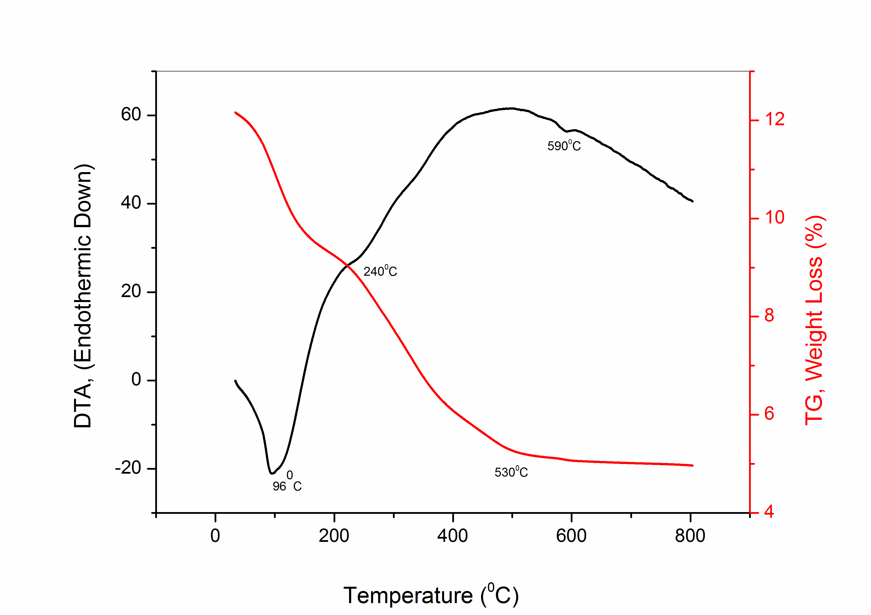
Figure 1. TGA/DTA analysis of the prepared gel samples prepared in a Nitrogen atmosphere with a heating rate of 5°C/min till 900°C.

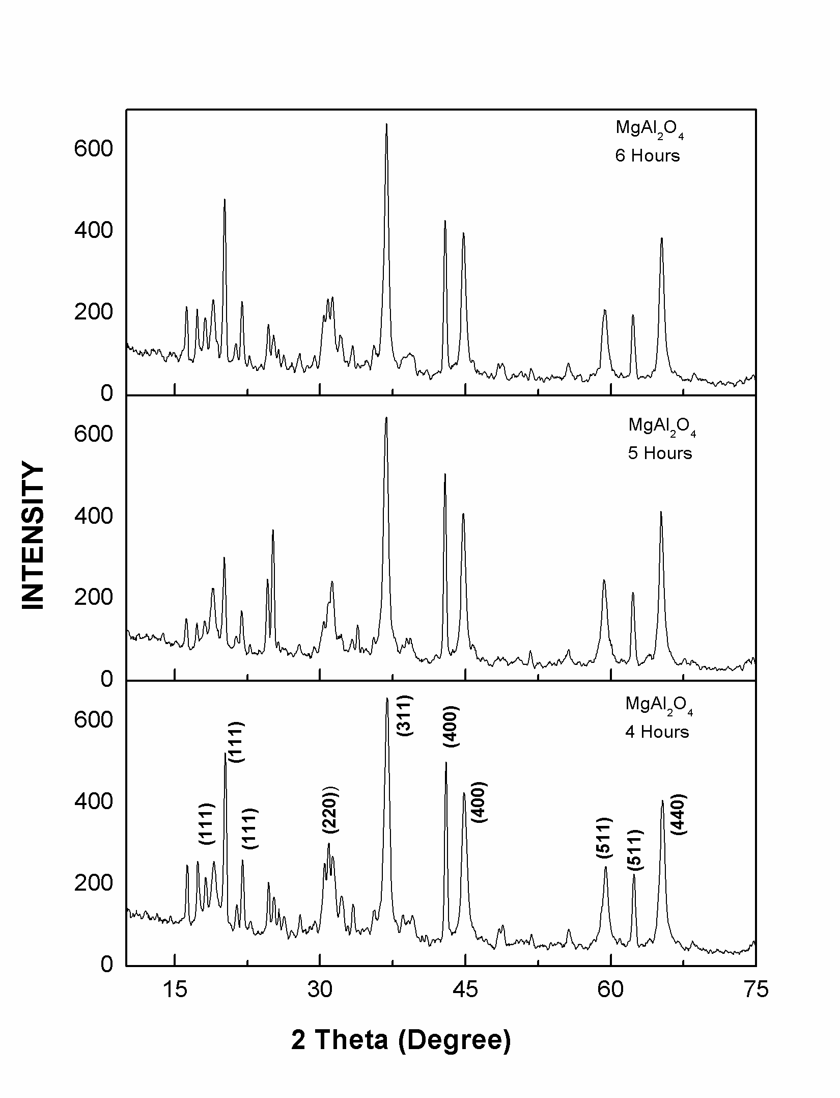
Figure 2. XRD analysis of the spinel powder prepared and calcined at 1000 °C for 6 hours, 5 hours and 4 hours respectively with 1:1 Mg nitrate, Al nitrate precursors.
aluminate synthesized using urea as fuel and reducing agent, octahedral M-O (Al-O) stretching was noted at about 539 cm⁻¹ while Mg-O-Al vibration is observed at about 677 cm⁻¹ . The majority of M-O coordination was found within 1000 cm⁻¹ as noted from the present experiment. Similar to the present experimental observations majority of M-O coordination were found within 1000 cm⁻¹. The above bonding analysis noted from FTIR spectra were noted to be in correspondence with research findings by the same author in other research articles (S.R. Ghosh et al. 2018; Mukherjee 2020). The band at 524 cm⁻¹, 671 cm⁻¹, and 1111 cm⁻¹ shows the stretching vibration of Al-O-Mg. It was also seen from the graph that 1485 cm⁻¹, 1651 cm⁻¹ , 3344 cm⁻¹ reflects H₂O stretching vibration. If we increase the soaking time, it was found that the peak at 1485 cm⁻¹ got eliminated from the graph which indicates that at a higher temperature the concentration of H2O was less. The presence of adsorbed moisture was noted since FTIR analysis was carried in the air atmosphere. If the analysis has been carried in a controlled atmosphere with neutral gas purging (Nitrogen/Argon) presence of adsorbed moisture on the powder surface have been eliminated.
Figures 4, 5, and 6 show the EDX analysis of the MgAl2O4 spinel nanoparticle synthesized by the sol-gel method at 1000°C and soaked for 4,5,6 h respectively. It was deduced from morphology that the grain size of the MA particle increases with increasing temperature with no change in phase indicating stabilization of crystal structure. The EDX spectra of the spinel powder calcined at 1000°C temperatures for different soaking times were taken at different positions. It is indicated that the cubic grain structures of spinel with a ratio of 1:1 Magnesium, Al precursors added were studied to observe the required elements present in the matrix as shown in morphology. EDX of different soaking time has been shown in Figs. 3, 4 and 5 respectively. All EDX spectra indicate the presence of Mg, Al, O elemental peaks in the sample. The intense stacking of the powder grains on each other was dominant in the figure where EDX spot analysis has been carried. XRD, FTIR and EDX analyses correlate with each other indicating successful phase formation of spinel using non-stoichiometric precursors.
Figure 7 shows the SEM of the MA spinel calcined at different soaking periods at a fixed temperature. The surface morphology of the powders magnesium aluminate spinel was investigated by Scanning Electron Microscopy (SEM). The morphological structure of the MgAl2O4 powder calcined at 1000ºC temperatures for different soaking time 4 h, 5 h, 6 h were exhibited by SEM. It can be seen from the figure that the spinel had become much more agglomerated in 5 h and 4 h soaking period in comparison to 6 h soaking. Minute observation reveals that some minor intergranular cracks were noted among agglomerated chunk for sample undergoing 5 h soaking while nil
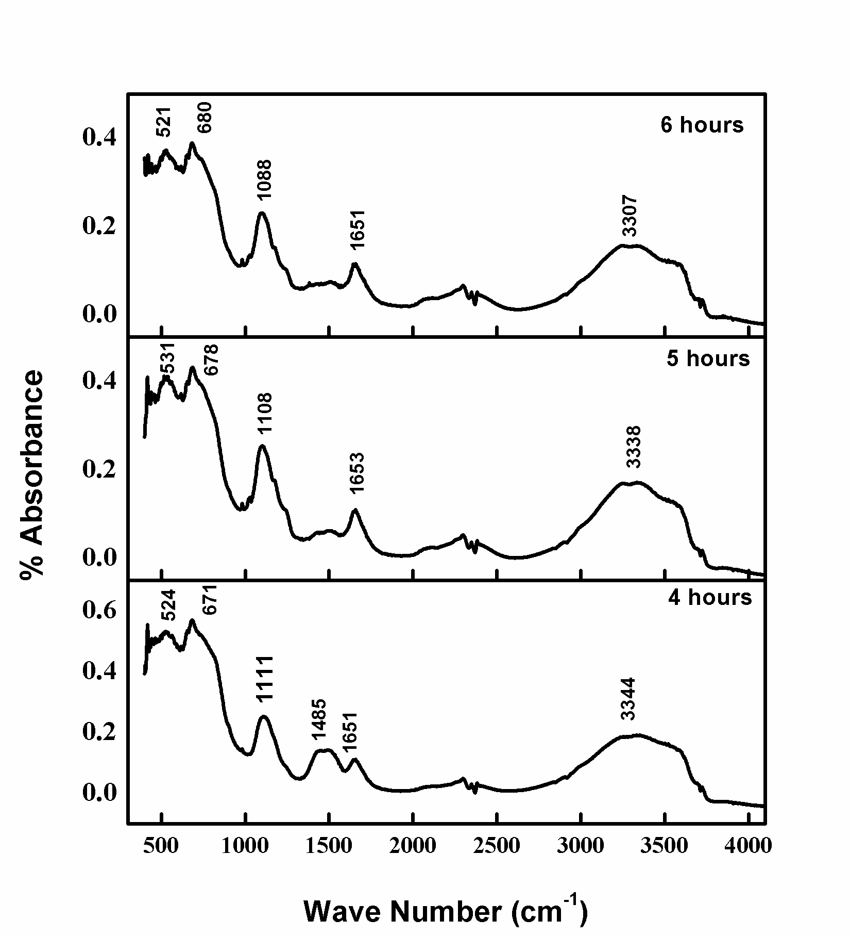
Figure 3. FT-IR spectra of MgAl2O4 product calcined at 1000°C prepared after annealing for 4 hours, 5 hours and 6 hours respectively with 1:1 non-stoichiometric ratio of Mg-Al nitrate precursors using thiourea as fuel.
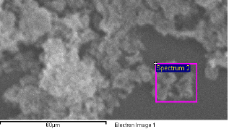
(a)

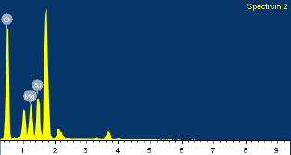
(b)

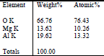
(c)

Figure 4. EDX analysis of the MgAl2O4 spinel nanoparticle synthesized by the sol-gel method at 1000°C for 4 hours.
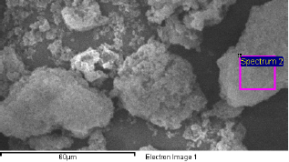
A
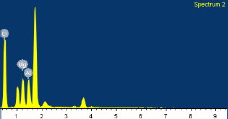
B
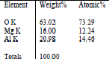
C

Figure 5. EDX analysis of the MgAl2O4 spinel nanoparticle synthesized by the sol-gel method at 1000°C for 5 hours.
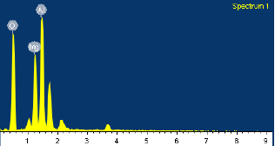
A
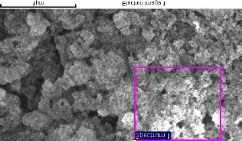
B
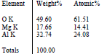
C
Figure 6. EDX analysis of the MgAl2O4 spinel nanoparticle synthesized by the sol-gel method at 1000°C for 6 hours.
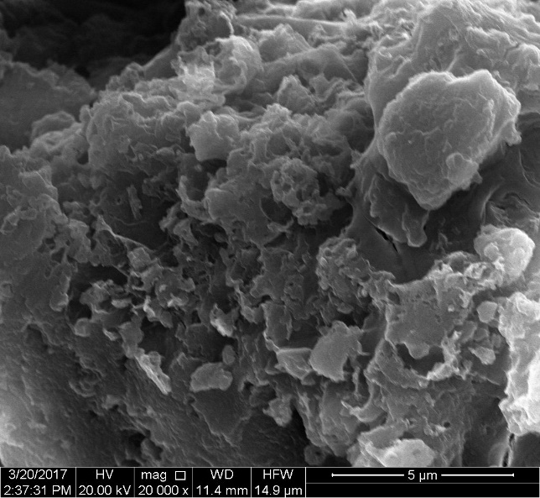
A

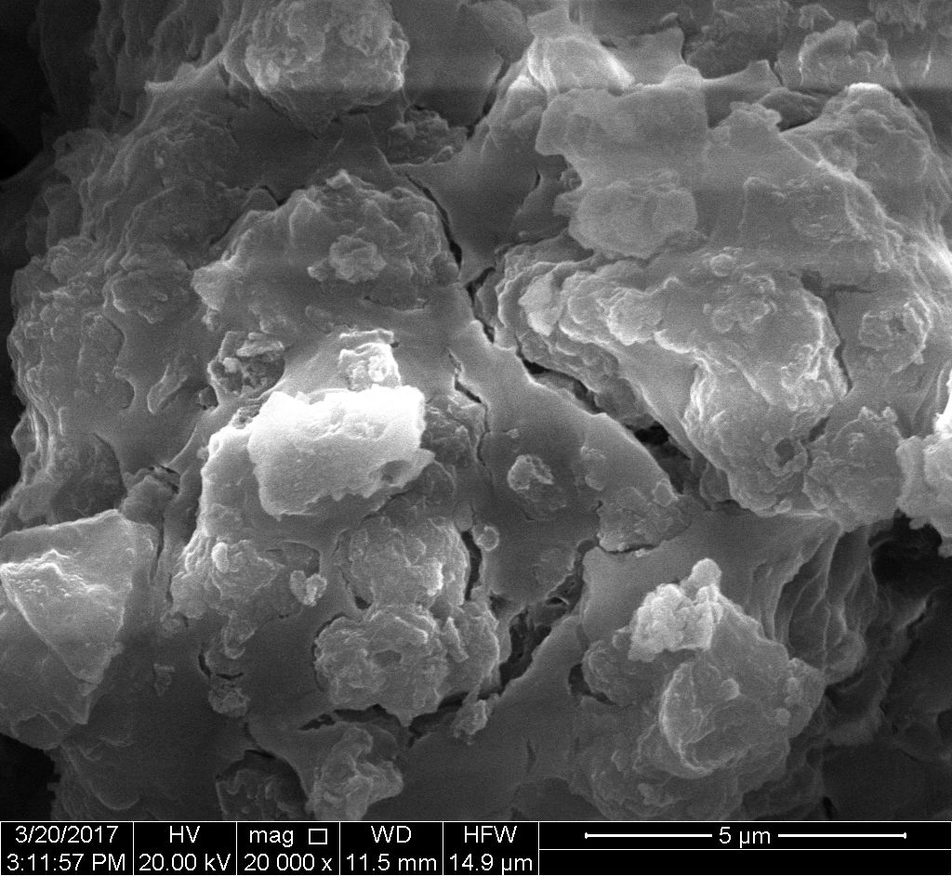
B

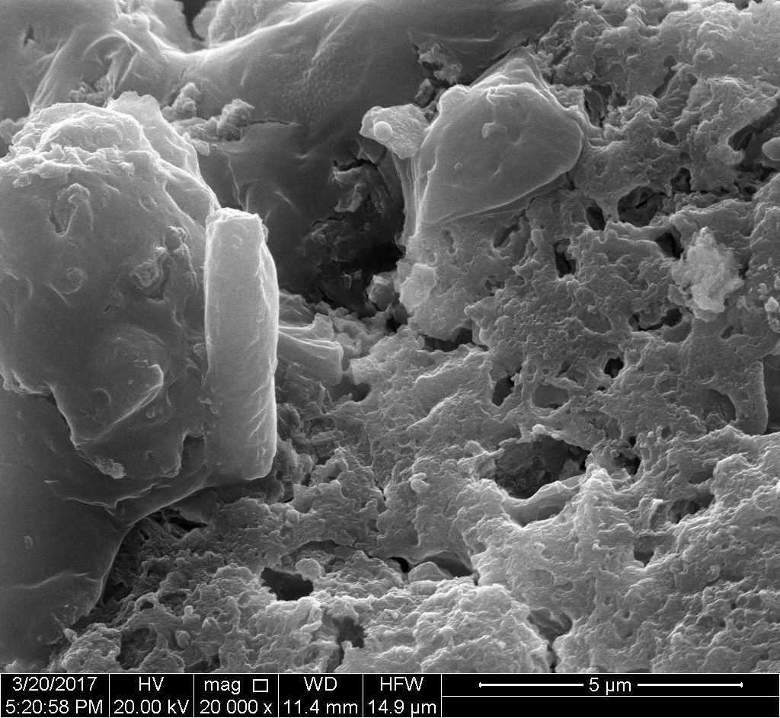
C
Figure 7. SEM morphology of Magnesium Aluminate (MA) Spinel calcined at the different soaking period of 4hours (A), 5 hours (B) and 6 hours (C) for the fixed temperature at 1000°C using 1:1 non-stoichiometric ratio of Mg:Al nitrates using thiourea as fuel
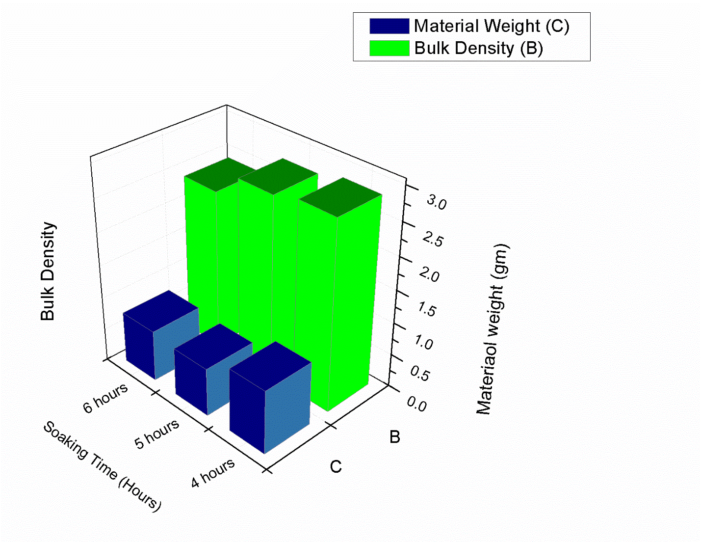
Figure 8. Variation of bulk density (BD), Material Weight and soak time of spinel grains by sintering at 1000°C function of the compact weight.

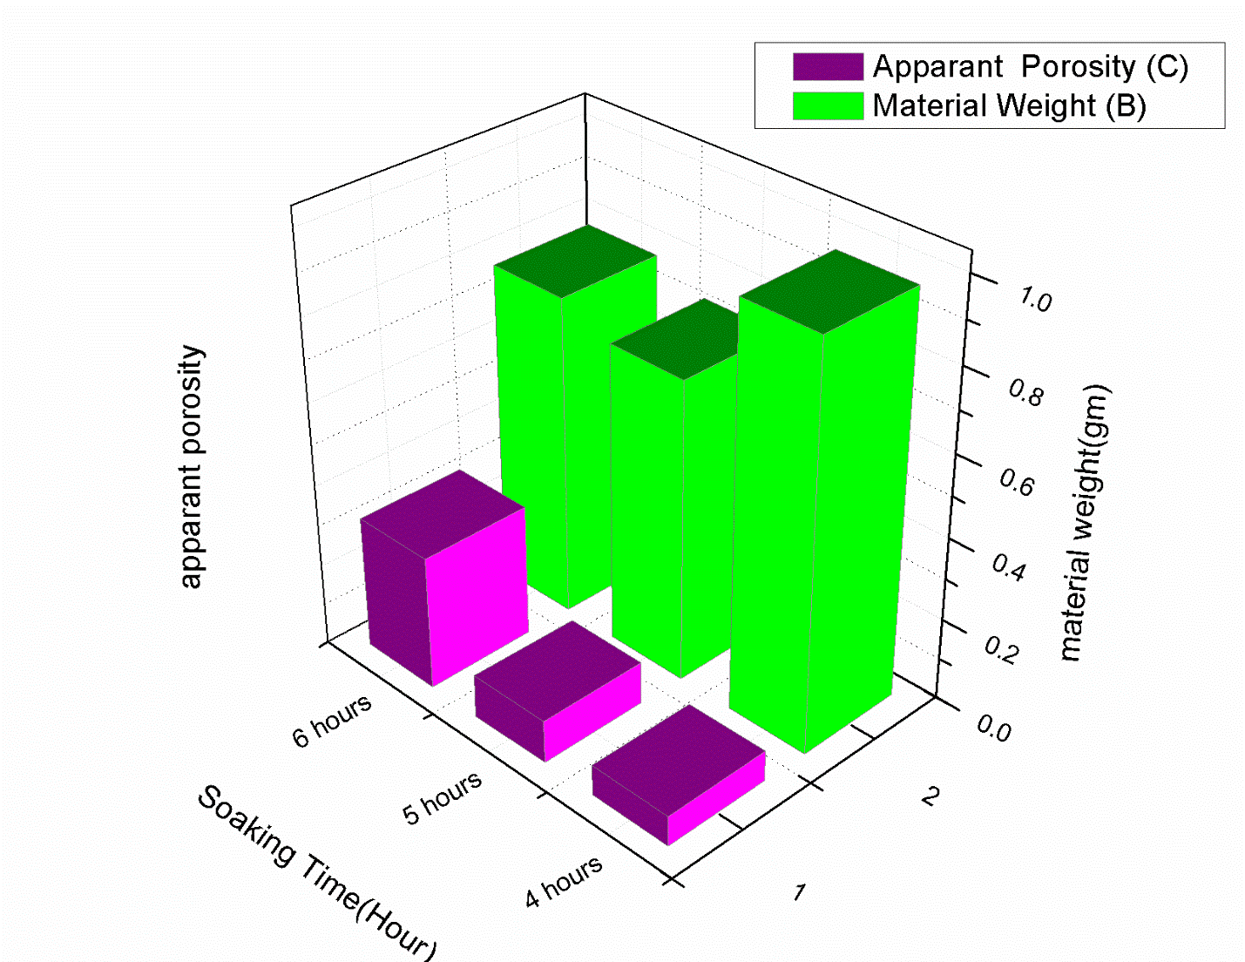

Figure 9. Variation of Apparent porosity (AP), and soak time of spinel grains on sintering at 1000°C at the function of the material weight.
Table 1. Dry and Wet Bulk Density, Apparent Porosity, Material weight of spinel soaked for different periods at fixed temperatureTable 1: Dry and Wet BuTable 1: Dry and Wet Bulk Density, Apparent Porosity, Material weight of spinel soaked for different periods at fixed temperature.
hrs | Dry Bulk Density (g/cm³) | Wet Bulk Density  (g/cm³) | Apparent Porosity | Material Weight (g)
4 | 2.8571 | 2.9325 | 0.0742 | 0.97
5 | 2.7609 | 2.8646 | 0.10363 | 0.73
6 | 2.4156 | 2.7407 | 0.3251 | 0.78
cracks or interconnected porosity was noted for sample undergoing annealing for 4 h. Nevertheless the sample prepared after soaking for 6 h exhibits less agglomeration. From this observation, we can conclude that soaking time at around 5 h gives us the desired spinel structure. The above morphological features were found to be tallying with density and apparent porosity variation noted for spinel samples heated at 1000°C for 4 h, 5h and 6 h soaking period. Such possible result may be due to the difference of thermal expansion behaviour of Al-based precursors and magnesium-based precursors and for maintaining non-stoichiometric ratio in comparison to stoichiometric ratio used for spinel formation.
Variation of bulk density (BD), Material Weight and soak time of spinel grains by sintering at 1000°C as a function of the compact weight was depicted in Fig. 8. Densities were calculated using the Archimedes principle. Here, the densities were changed from 2.4156 g/cm3 to 2.8571 g/cm3 with sintering temperature 1000°C. According to the literature [5], the values of the bulk densities were obtained around 3 g/cm3 for the MgAl2O4 spinel. The density of the sample is maximum for 4 hours sample while least for 6 hours soaking period. The density variation commensurate with the morphological findings from SEM analysis.
Figure 9 shows the apparent porosity (%) values of sintered samples soaked at different temperatures. The apparent porosities of samples were decreased with increasing sintering temperature. These results have shown that the samples were sintered better with increasing temperature. Sinhamahapatra et al. [6] have produced the magnesia-rich magnesium aluminate spinel with the natural magnesite and the synthetic caustic magnesia. However, spinel and periclase and forsterite were found in the samples due to the presence of silica as impurities. In our study, Magnesium aluminate spinel was formed at 1000°C. The decrease in apparent porosity of samples from 4 h to 6 h indicates that the densification occurred through liquid phase sintering (Fig. 6). Apparent porosity and bulk density were two vital parameters to assess the extent of densification of ceramic compacts. The variation of apparent porosity and bulk density of spinel samples with sintering temperatures were shown in Figs. 7 and 8. It reveals that for SS composition highest bulk density of 2.8571 was achieved at1000°C with a soaking time of 4 h and a slight decrease in bulk density value of 2.7609 and 2.4156 at 5 h and 6 h soaking respectively was observed. The rapid increase in apparent porosity of samples 7.4289%, 10.3630% and 32.51% for 4h, 5 h and 6 h respectively also indicates that high soaking time affects apparent porosity. It was also noted that variation of apparent porosity with soaking time was in correspondence with morphological findings from SEM analysis. Finally, the hardness of pellet samples of spinel was carried by Vicker’s hardness testing. At first, the powder material is properly mixed with 1.5% PVA (Polyvinyl alcohol). The mixture is then dried and ultrasonicated to loosen its agglomerated particles. Then the mixture is pressed with 4-ton pressure to make a pellet. After that, the pellet is sintered at 1200°C for 30 minutes to remove the PVA present inside the pellet. At high temperature, various particles present in the material rearranged their bonding which made the material denser. Corresponding hardness values were evaluated as 10.52 GPa (1073 HV), 4.087 GPa (416.7 HV) and 5.079 GPa (517.9 HV). Sample synthesized after soaking at 4 h show more hardness than the powder soaked at 5 h and 6 h. This will suggest that crystal size will increase as well as hardness will decrease if we increase the soaking time.

CONCLUSION

Non stoichiometric1:1 ratio of Magnesium nitrate, Al nitrate along with thiourea as fuel and the reducing agent was utilized to synthesis spinel magnesium aluminate. Crystallization for spinel onset was in the range 500-700°C with a minor endothermic peak at 590°C. Proper phase for spinel was developed even with non-stoichiometric precursors at 1000°C after soaking for 4 h, 5 h and 6 has confirmed from XRD. The Crystallite size of corresponding spinel particles was about 48 nm, 36 nm and 47 nm respectively. FTIR analysis confirmed the M-O coordinations and it was noted that Al-O coordination was about 539 cm⁻¹ while Mg-O-Al vibration was observed at about 677 cm⁻¹. Morphology analysis by SEM reveals that spinel becomes more agglomerated in 5 h and 4 h soaking period in comparison to 6 h soaking. Minute analysis reveals minor intergranular cracks for samples undergoing 5 h soaking. EDX confirms the elemental composition analysis. Bulk densities were estimated from 2.4156 g/cm3 to 2.8571 g/cm3. The rapid increase in apparent porosity of samples were 7.4289%, 10.3630% and 32.51% for 4 h 5 h and 6 h, respectively. Bulk density and apparent porosity results were found to be in tallying with microstructural features obtained after synthesis using non-stoichiometric ratio and thiourea as fuel. Hardness values were evaluated as 10.52 GPa (1073 HV), 4.087 GPa (416.7 HV) and 5.079 GPa (517.9 HV) in the form of a pellet sample by Vicker hardness tester.

CONFLICT OF INTEREST
The authors declare no conflict of interest.

FUNDING
No funding was received for this study.

ACKNOWLEDGMENT
The authors would like to thank the Department of Metallurgical & Material Engineering for providing technical support to carry out DSC-TGA analysis, XRD, FTIR and morphology studies by SEM.

REFERENCES
Barj M, Bocquet J.F, Chhor K, Pommier C, (1992), Submicronic MgAl2O4 powder synthesis in supercritical ethanol. Journal of Materials Science 27: 2187-2192.
Bickmore R Clint, Waldner F. Kurt, Treadwell R. David, Laine M. Richard, (1996), Ultrafine Spinel powders by Flame Pyrolysis of a Magnesium Aluminium Double Hydroxide. Journal of the American Ceramic Society 79(5): 1419-1423.
Bratton R.J, (1969), Coprecipitates yielding MgAl2O4 powders. American Ceramic Society Bulletin 83: 759-762.
Domanski Daniela, Urretavizcaya Guillermina, Castro J. Facundo, Gennari C. Fabiana, (2004), Mechanochemical Synthesis of Magnesium Aluminate Spinel Powder at Room Temperature. Journal of the American Ceramic Society 87(11): 2020-2024.
Du Xuelian, Liu Yaqiang, Li Liqiang, Chen Wencong, (2014), Synthesis of MgAl2O4 spinel nanoparticles via polymer-gel and isolation –medium-assisted calcination. Journal of Materials Research 29(24): 2921-2927.
Ghosh Chandrima, Ghosh Arup, Halder Manas Kamal (2015), Studies on densification, mechanical, micro-structural and structure properties relationship of magnesium aluminate spinel refractory aggregates prepared from Indian magnesite. Materials Characterization 99: 84-91.
Ghosh S.R, Mukherjee S, Banerjee S (2018), Solution combustion synthesis of Alumina spinel and its characterization. Interceram 67: 34-41.
Gorshkov V.A, Miloserdov P.A, Yukhvid V. I, Sachkova N.V, Kovalev I.D, (2017), Preparation of magnesium aluminate spinel by self-propagating high temperature synthesis metallurgy methods. Inorganic Materials 53: 1046-1052.
Habibi Narges, Wang Yuan, Arandiyan Hamidreza, Rezaei Mehran (2017), Low temperature synthesis of mesoporous nanocrystalline magnesium aluminate (MgAl2O4) spinel with high surface area using a novel modified sol-gel method. Advanced Powder Technology 28: 1249-1257.
Lazau Ioan, Ianos Robert, Pacurariu Cornelia, Savii Cecilia, (2008), Spinel preparation by combustion synthesis: The influence of synthesis conditions on the features of the resulted spinel MgAl2O4 powder. Romanian Journal of Materials 3: 224-232.
Lee P.Y, Suematsu H, Yano T, Yatsui K, (2006), Synthesis and Characterization of nanocrystalline MgAl2O4 spinel by polymerized complex method. Journal of Nanoparticle Research 8: 911-917.
Macêdo Maria laponeide Fernandes, Bertran Celso Aparecido, Osawa Carla Cristiane, (2007), Kinetics of the γ → α-alumina phase transformation by quantitative X-ray diffraction. Journal of Materials Science 42: 2830–2836. https://doi.org/10.1007/s10853-006-1364-1
Marakkar Kutty P V, Dasgupta Subrata (2013), Low temperature synthesis of nanocrystalline magnesium aluminate spinel by a soft chemical method. Ceramics International 39(7): 7891-7894.
Mukherjee Soumya, (2020), Evolution of Spinel Magnesium Aluminate by Combustion route using Glycine as Fuel and its characterization. International Journal of Emerging Trends in Science and Technology 6(1): 24-27.
Nassar Y. Mostafa, Ahmed S. Ibrahim, Samir Ihab (2014), A novel synthetic route for magnesium aluminate (MgAl2O4) nanoparticles using sol-gel auto combustion method and their photocatalytic properties. Spectrochimica Acta Part A: Molecular and Biomolecular Spectroscopy 131: 329-334.
Păcurariu C, Lazău I, Ecsedi Z, Lazău R, Barvinschi P, Mărginean G, (2007), New Synthesis methods of MgAl2O4 spinel. Journal of the European Ceramic Society 27: 707-710.
Patil Kashinath C, Aruna S. T, Mimani Tanu, (2002), Combustion synthesis: An update. Current Opinion in Solid State and Materials Science 6: 507-512.
Pommier C, Chhor K, Bocquet J.F, Barj M, (1990), Reactions in supercritical fluids, a new route for oxide ceramic powder elaboration, synthesis of the spinel MgAl2O4. Materials Research Bulletin 25(2): 213-221.
Saberi Ali, Golestani-Fard Farhad, Sarpoolaky Hosein, Willert Porada Monika, Gerdes Thorsten, Simon Reinhard (2008), Chemical synthesis of nanocrystalline magnesium aluminate spinel via nitrate-citrate combustion route. Journal of Alloys and Compounds 462: 142-146.
Salem Shiva (2015) Application of autoignition technique for synthesis of magnesium aluminate in nano scale: Influence of starting solution pH on physico-chemical characteristics of particles. Materials Chemistry and Physics 155(1): 59-66.
Salem Shiva, Nouri Babak, Ghadiri Mohammad, (2020), Photoactivity of magnesium aluminate under solar irradiation for treatment of wastewater contaminated by methylene blue: Effect of self-combustion factors on spinel characteristics. Solar Energy Materials and Solar Cells 218: 110773.
Torkian Leila, Amini M Mostafa, Bahrami Zohreh,
(2011), Synthesis of Nano Crystalline MgAl2O4 powder by Microwave assisted combustion. Journal of Inorganic Materials 26(5): 550-554.
Varnier Olivier, Hovnanian Nadine, Larbot André, Bergez Pierre, Cot Louis, Charpin Jean, (1994), Sol-gel synthesis of magnesium aluminum spinel from a heterometallic alkoxide. Materials Research Bulletin 29(5): 479-488.
Yang Ning, Chang Li, (1992), Structural inhomogenity and crystallization behavior of aerosol reacted MgAl2O4 powders. Materials Letters 15(1-2): 84-88.
Zhou Wenying, Yan Wen, Ma Sanbao, SchaffÖner Stefan, Dai Yajie, Li Yawei, (2021), Degradation mechanisms of periclase-magnesium aluminate spinel refractory bricks used in the upper transition zone of a cement rotary kiln. Construction and Building Materials 272: February 2021: 121617.

