Incomes of Refugees in Canada

Interventions that provide social and financial capital can help refugees and protected persons achieve significantly higher incomes in Canada.
This is the second report in the Social Policy Trends series to investigate the impact of social agencies on the economic and social inclusion of newcomers to Canada. In the June report, we covered the role of career planning, coaching, and mentorship services in the economic success of immigrants to Canada. In this report, we focus specifically on refugees, who come to Canada fleeing persecution and war in their home countries.
Refugees are admitted to Canada through the resettlement process, where the Canadian government or private sponsors select and relocate them to Canada. Refugees can also arrive as asylum seekers and go through a court-like process to assess the credibility of their case. If they receive a positive decision, they may apply for permanent residency and with a path to citizenship.
Incomes of refugees are typically stagnant after arriving in Canada. Interventions including low-interest microloans and career actions plans break this trend and help refugees earn higher incomes.
Refugees face additional barriers to full inclusion in Canadian socioeconomic life compared to other newcomers. They have less access to transcripts or job histories from their home countries. Many left financial assets in their home countries and rely on the support of sponsors during their first years in Canada. These and other factors may limit their ability to seek higher paying jobs or the training necessary to achieve them. One result of this is lower incomes. The median income of a refugee is $27,000 per year after 10 years living in Canada, $13,600 less than the national median income.
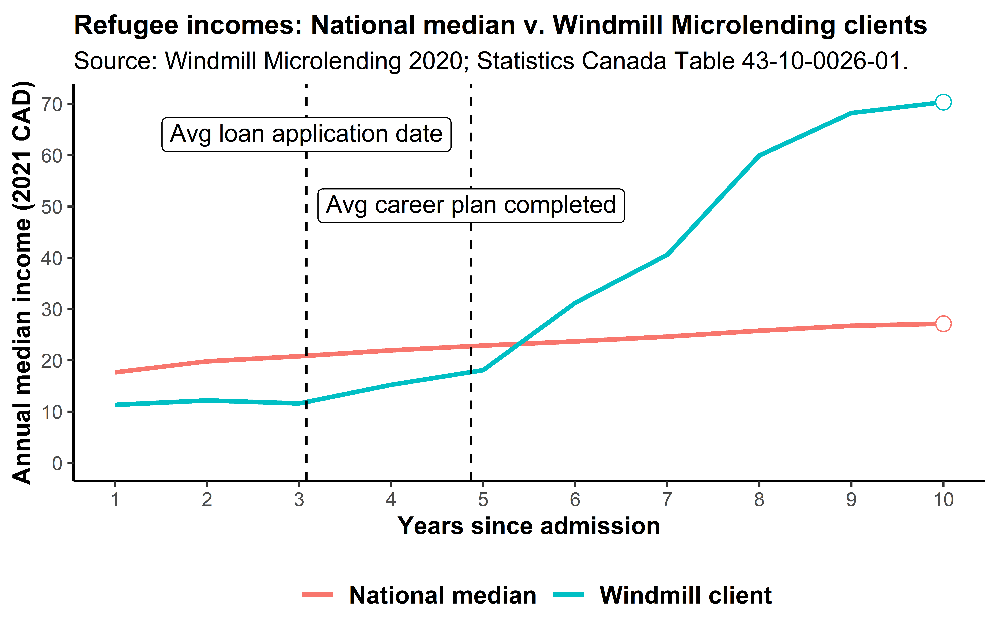
The above data shows how outside interventions can break the trend in stagnancy and help refugees achieve higher incomes. It shows the median annual incomes for refugees at the national level compared to refugee clients of Windmill Microlending, a registered charity that provides newcomers with low-interest loans and value-added services to direct their career path. The red line shows the previously described national median for refugees. The blue shows how clients of Windmill follow a similar trend, but at a lower level, before receiving help from Windmill. The average Windmill client completes their career success plan after 4.9 years of living in Canada; as shown in the figure, this is when incomes begin to rapidly climb, resulting in a median income of $70,000 after 10 years in Canada.
Private and public funders of Windmill and other social agencies should find it in their best interests to support these programs and help refugees earn higher incomes. After enduring conflict in their home countries refugees can achieve their full potential. There is also a greater return to Canada – refugees that are more integrated into the Canadian economy provide residents with goods and services to a greater degree, and governments see higher tax revenues. Financially supporting these programs may therefore be seen as both a social good and an investment.

