**Analysis of wave added resistance and motion response of fishing boat sailing against waves**

1Wang Jing, 2Zhou Yu

1(China Institute of Marine Technology and Economy Beijing 100081)

2(Jiangsu Shipping College Nantong Jiangsu 226010)

**Abstract**：In order to accurately predict the on wave resistance and responses to hull motions of ships in actual sea conditions, the k-εmethod of RNG model is adopted on the basis of the unsteady RANS method. The two-formula turbulence model deals with viscous flow, the VOF method captures the free surface, the velocity boundary method makes waves, the artificial damping method is used to eliminate waves, and the nested grid technology is used to deal with the motion response of ships on waves. Combined with the 6-DOF motion formula, a three-dimensional numerical wave cell for regular waves is established. For one example, taking a fishing boat sailing at a high speed, the increase of wave resistance and motion response at different wavelengths are analyzed, and the simulation results are compared with the content of strip theory in potential flow theory and the panel method to prove the reliability of CFD method in predicting ship motion.

**Key words**: CFD method; Wave added resistance; Motion response; Numerical pool; numerical simulation

**1.Introduction**

In the actual navigation process, the ship will be affected by waves of different degrees and some movement phenomena, such as heave and pitch. These motions will not only increase the resistance of the ship and reduce the propulsion efficiency, but also affect the normal operation of the equipment on the ship and the working efficiency of the crew, and even cause the ship to capsize. Therefore, accurate prediction of the motion performance of hull is very vital for ship design. Therefore, the study of ship motion characteristics in waves has become current hot spots in academic research[1]. The traditional method of studying ship motion performance is based on potential flow theory and model test. The theory based on potential flow has been widely used for its convenience and rapidity. Particularly in that initial design stage of a ship, in order to quickly obtain the motion performance of ships, it has been favored by ship designers. However, because there is a big error between the numerical simulation results and the theoretical calculation results, it is difficult to accurate prediction of nonlinear results such as the increase of ship motion amplitude, wave breaking and waves on the deck[2].Therefore, it is very important to obtain more flow field information at the stage of ship detailed design. Although the calculation results of the model experiment are accurate, due to a large number of manpower and costs, it cannot meet the requirements of the current fierce market competition for rapid acquisition of new ship types. In recent years, with the rapid development of computer technology and mathematical knowledge, using CFD technology to predict wave resistance and motion performance has become a reality. CFD method not only considers the viscous effect, but also fully considers the nonlinear effect, so it has been widely used. Many research results have been published at home and abroad to predict wave resistance and motion performance using CFD.In foreign countries, for RANS formula, it is solved by Orihara and Miyata[3] through the finite volume method, and used the overlapping grid technology to simulate and calculate the wave resistance and motion of container ships in regular waves; The numerical value of the DTMB5512 ship type large-amplitude motion is calculated and summarized by Carrica and Wilson[4] ,which is at medium and high speed, using the overlapping grid technology; Tezdogan and Kemal Demirel[5] and others evaluated the resistance and motion of container ships at low speed following the waves using the unsteady RANS method.In China, the CFD solver naoe-Foam-SJTU independently developed by Shen Zhirong[6] team based on the open-source code OpenFOAM can well predict the motion performance of ships and marine engineering, and has been verified by experiments. Zhao Invention[7] and others developed a CFD hydrodynamic performance calculation system for ships based on the RANS method of overlapping grids, which can well simulate the resistance and response of ship motion; Shi Bowen[8] and others set up a three-dimensional numerical simulation wave-making water channel based on the viscosity principle. In this way, the performance of ship navigation in irregular waves is simulated. However, the resistance and response of different ship types moving on the waves are different. The fishing boat is a high-speed ship, and there are few detailed studies on wave resistance and motion response. Based on the above conditions and experience, this paper numerically simulates the motion of fishing boats in waves in a six-degree-of-freedom regular wave numerical pool based on unsteady RANS method, calculates the wave resistance and motion response, and verifies the reliability of this method by numerical calculation. The numerical calculation methods here include strip theory method and panel method. The research results of this paper can provide technical support for the design and optimization of similar ships.

**2.** **Basic theory of CFD**

The formulas followed in the calculation domain of the whole simulated pool are the continuity formula and N-S formula, and the turbulence model adopts the k method of RNG - ε.In the model, capture free liquid surface by multiphase flow model method. And the wave is generated at the given wave velocity at that border of the speed inlet, and factitious damping setting is added wave pool exit area for wave attenuation.

**2.1** **Control formula [9]**

 （1）

 （2）

Where: ux, uy, uz - velocity components in x, y and z directions; T - time; ρ- Is the quality density of fluid; -- Reynolds mean velocity；-- Reynolds stress.

**2.2Turbulence model**

The turbulence model adopts the k method of RNG - ε.In the model, the turbulent energy formula and energy consumption formula are in the following form [10]:

 （3）

 （4）Where:；, -- The reciprocal of turbulence kinetic energy's effective prandtl number and turbulent dissipation rate;

**2.3** **Free Face Snap**

Under the condition of keeping the Euler grid unchanged, the interface between the ship and the water surface is captured by free following of the hull surface, which is called VOF method. It can be used to simulate the multi-flow model by finding the solution of the momentum formula and volume fractions of a fluid or fluids. In any control volume, the sum of the volume fractions of all phases must be 1. For the each qth phase, the formula is:

 （5）

 （6）

Where: a1 and a2-are the volume fractions of water and air respectively, and aq=0.5, which is the limiting surface between water and air; q=0 - which represents that entire computing domain is water; q=1 - which represents that th entire computing domain is air.

**2.4 Wave making and wave absorption**

This wave-making adopts the velocity boundary method, which makes waves by giving the wave velocity at the boundary of the velocity entrance[12]. Compared with the physical test pool, It has high economic value, convenient operation, high calculation accuracy and slow attenuation.. At the same time, this method is easier to give a fixed the velocity of the vessel at the entrance boundary, which can avoid difficulties brought form moving the boundary, which is another advantage compared with the simulated physical method.

The wave surface formula is:

 （7）

The speed influences are as follows:

 （8）

 （9）

Where: a is wave amplitude. K=2 π/ λ determine, which is called wave number. ω 0 - natural frequency of wave,. ωe can be calculated by formula:ωe＝ ω0+kU, which is called the frequency of a wave as measured by its relative velocity and wavelength.This equation shows that ωe varies with the change of the velocity of the vessel U.

The expression of artificial damping coefficient μ is as follows:

（10）



Where: xf ≤ x ≤ xa (f and a are the two endpoints of the resistance region in the X direction, separately); zd ≤ z ≤ zu (d and u are the bottom along the y direction and the intersection of water and air separately); α is the damping control parameter.

**2.5 DOF equation of motion**

When establishing the ship motion formula, two reference coordinate systems are established. One is the fixed coordinate system OoXoYoZo, which is fixed on the earth; The other is the ship moving coordinate system GXYZ, which is fixed on the ship[13]. The origin of the moving coordinate system is located at the center of gravity G of the ship, where Gx, Gy and Gz are the intersection lines of the longitudinal section, the transverse section and the horizontal liquid level passing through the center of gravity G, respectively, and the downward direction of the Z axis is positive.

 （11）

 （12）

Where, Ω is the angular velocity, B is the ship's moment, F is the additional force, U is the ship's speed, K is the moment of momentum, and M is the sum moment.

**3.** **Example**

The wave resistance and body responses of high-speed fishing boats sailing in waves are calculated. Figure 1 shows the fishing boat’s geometric model. And the main dimensions and hull form parameters are shown in Table 1.

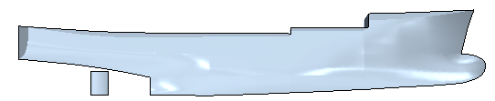

Fig1. Geometric model of the fishing vessel

Table 1. The fishing vessel’s main dimensions and hull form parameters

|  |  |  |  |  |
| --- | --- | --- | --- | --- |
| Parameter | Full-scale ship | Model | | Unit |
| Length between perpendiculars（LPP） | 34.5 | 4.8 | | m |
| Draft（d） | 2.5 | 0.35 | | m |
| Moulded width（B） | 7.6 | 1.06 | m | |
| Square coefficient（CB） | 0.597 | 0.597 | - | |
| Displacement (△) | 425 | 1.45 | t | |
| Wet surface area（S） | 324 | 6.27 | m2 | |
| Design speed | 35 | 13 | kn | |

**3.1** **Calculation domain and boundary conditions**

According to the symmetry of the hull, it can be assumed that the flow field is also symmetrical in the numerical simulation, and the symmetry plane is the X-Z plane. Considering the parameters such as wavelength, period and wave height of simulated linear waves, taking half of the hull as the calculation domain can effectively improve the calculation speed. Taking the calculation range of 4.5L×2.0L×2.5L (where L is the captain and the unit is m) as the whole calculation domain, that is, the numerical simulation research object. The distance between the bow and the pool entrance is L, and the simulated water depth is 1.5L. The specific dimensions are shown in Figure 2. The upper part of the computational domain is air and the lower part is water.

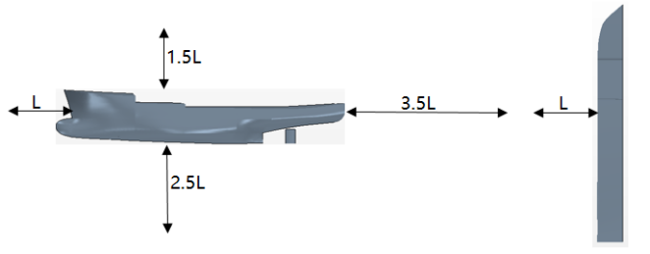 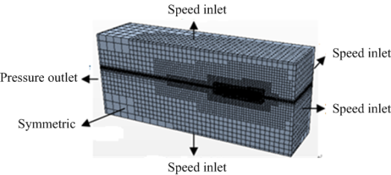

1. (b)

Fig2. Calculation domain and boundary conditions

The boundary setting of velocity inlet is applied to the front surface, upper surface and lower surface of numerical simulation wave pool respectively, and the inflow velocity is added to the boundary of the front surface, which is the velocity of the vessel. Attach the pressure outlet parameter to the rear surface. Attach a rigid surface (wall) parameter to the surface of the boat. Finally, the calculation domain is set to be symmetric on the boundary of the middle longitudinal profile and its opposite sides.

**3.2** **Meshing**

Meshing is an essential part of the numerical simulation process. If you change the density and form of the grid, it will change the overall simulation time and the judgment of the results. Therefore, only by grasping the effect of the grid can you control the accuracy and reliability of the calculation results. In this paper, the embedded grid technology is applied in the commercial software STAR-CCM+, and static and dynamic grids are established. As to better analyze the ship's trajectory and sway on waves. Among them, static grids sparsely drawn, and dynamic grids can be densely drawn with encrypted grids. Overlap and background grid junction should be excessive according to a constant ratio. Interface between air and water must be no less than 80 grilles in the wavelength distance and no less than 20 gratings in the peak to trough range. Considering the machine configuration and simulation time, the total number of grids finally determined is 1.85 million. Figure 3 shows the grid near the free surface. As can be seen from the figure, the closer to the hull, the more dense the grid, and the farther away from the hull, the more sparse the grid. Figure 4 shows the size and shape of the hull surface grid. And grid encryption is needed at the bow and stern.

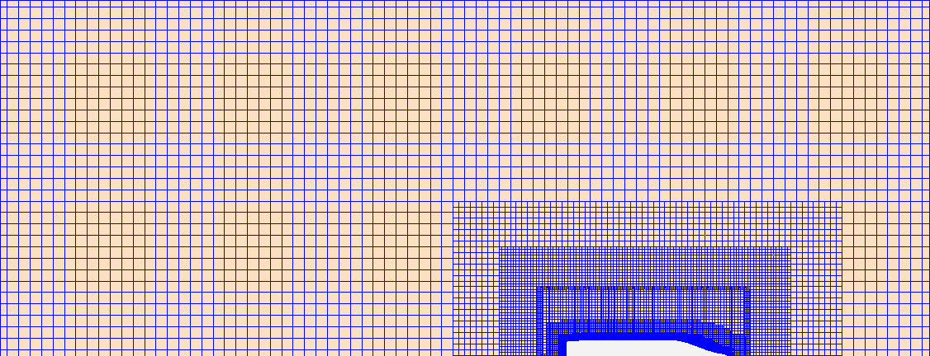 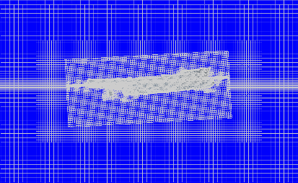

Fig3. Grid division of free surface and longitudinal section

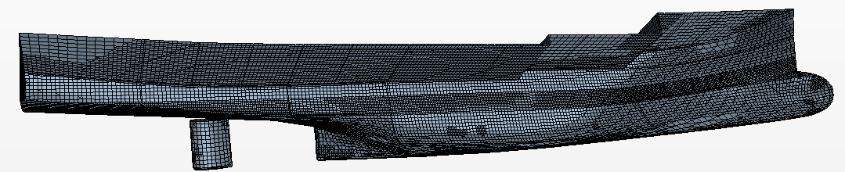

Fig4. Hull grid division

**3.3** **Grid independence check**

Mesh number has a great impact on the calculation results. The number of grids is too large, which wastes computing resources, is too small, and the results are inaccurate. As a result, it is essential to find a number of grids appropriately. In this paper, five types of grids are calculated respectively, and the calculation grid with less influence on the calculation results due to the increase of grid is obtained. Future calculations are based on this grid. The calculation results are shown in Figure 5.

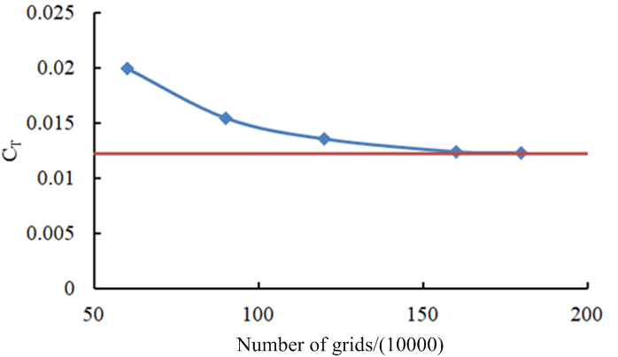

Fig 5. Grid independence

**3.4** **Calculation conditions of wave drag increase**

This paper mainly simulates the motion law of fishing boats under different wavelength length ratio and different wave steepness. Take the wavelength to length ratio:λ/ L=0.75,λ/ L=1.00,λ/ L=1.25,λ/ L=0.50,λ/ L=7.75,λ/ L=2.00; and wave steepness: 0.0175, 0.035, 0.0775, 0.0875 as the calculation conditions. The volume fraction of fishing boats is shown in Figure 5.

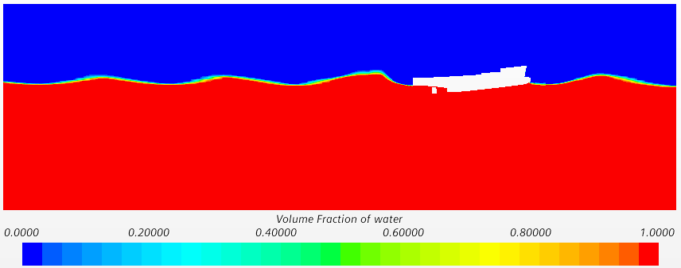

Fig5. Volume fraction of the fishing vessel

**4.** **Analysis of simulation results**

Figure 6 shows the relationship between the shear stresses received by the fishing boat hull over a period of time. It can be seen from the figure that the hull shear stress will change continuously with the wave peak and its steepness, especially the bow will bear huge shear stress in 1/4-1/2 cycle, because the bow is located at the wave peak position at this time, and there will be phenomena such as burying the bow or wave on the deck.

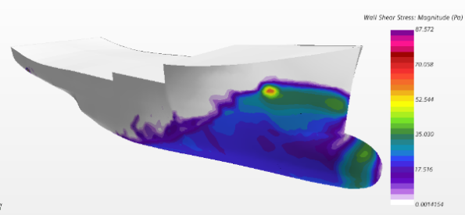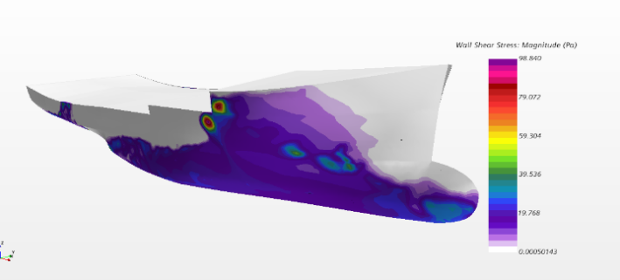

(a)t/Te=0.00 (b)t/Te=0.25

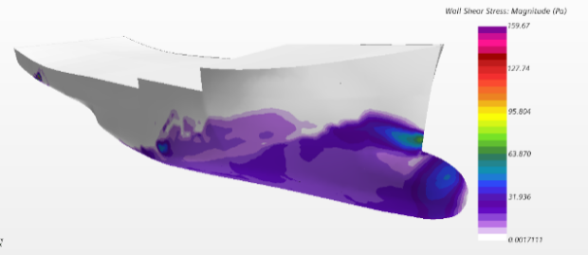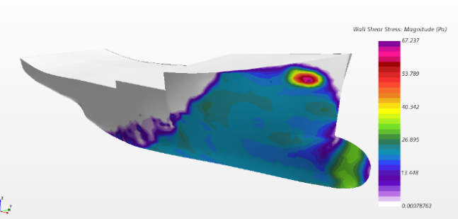

(c)t/Te=0.50 (d)t/Te=0.75

Fig 6. Change of hull shear stress over a period of time (Fn=0.28, λ/ L=1.0)

Figure 7 shows the change relationship of the free surface of the hull over a period of time. It can be seen from the figure that the change of draught at the bow and both sides of the hull can clearly show severe heave movements and pitch movements. In addition, waves appeared on the deck. The severe pitching motion may cause the bulbous nose to constantly enter and exit the water surface, resulting in a loud bang on the head, which will worsen the seakeeping of the ship.

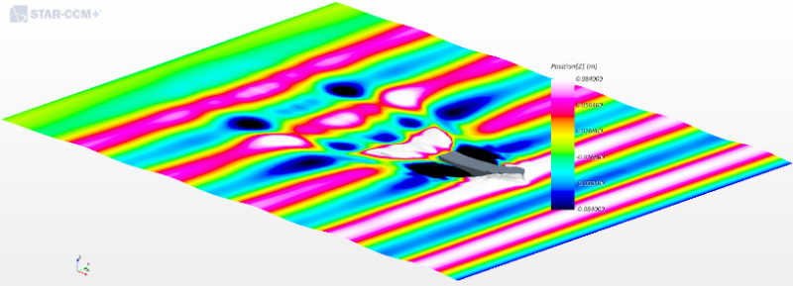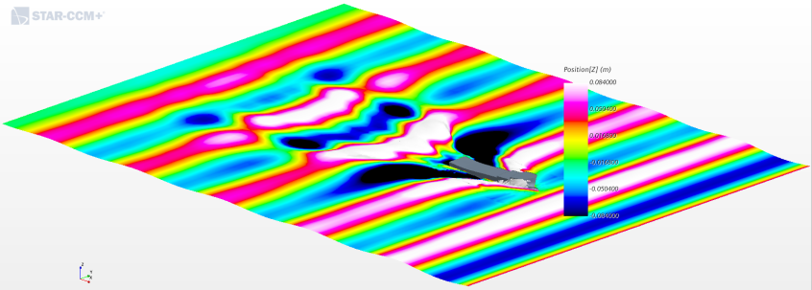

(a)t/Te=0.00 (b)t/Te=0.25

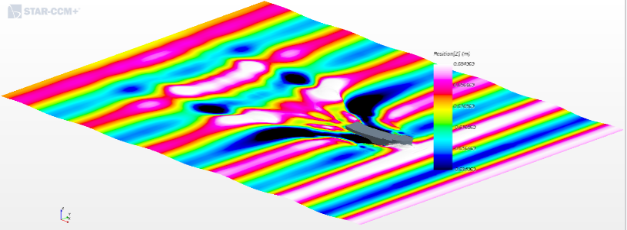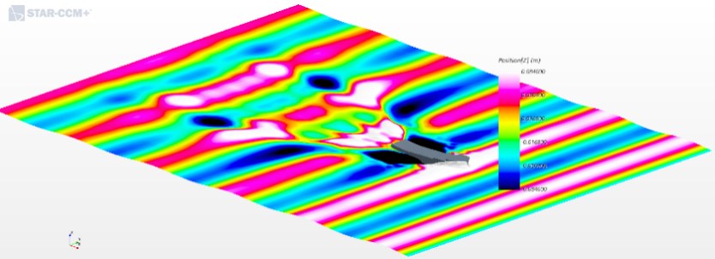

(c)t/Te=0.50 (d)t/Te=0.75

Fig7. Waveform of interface between water and air in one cycle (Fn=0.28, λ/ L=1.0)

Figure 8, Figure 9 and Figure 10 are the comparison of the CFD simulation results of the heave, pitch transfer function and wave resistance coefficient of fishing vessels using the slice theory and the panel method respectively. It can be seen from the figure that the calculation curve trend of the three methods is basically the same, and they can well predict the relationship between heave, pitch and wave resistance with the increase of wavelength-to-length ratio. The accuracy of the CFD calculation method has been confirmed by engineering practice, so the CFD simulation results should still prevail in the absence of test values. In addition, the heaving and pitching relationships of the fishing vessel under different wave steepness are also studied. As can be seen from the figure 11, the heave of the ship increases slowly and gradually with the increase of wave steepness. In contrast, the pitching of a ship increases rapidly and gradually with the steep waves.

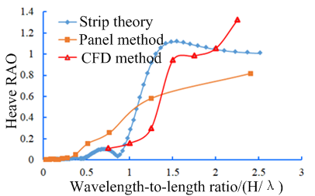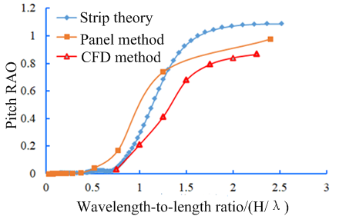

Fig8.The heave transfer coefficient Fig 9. The pitch transfer function

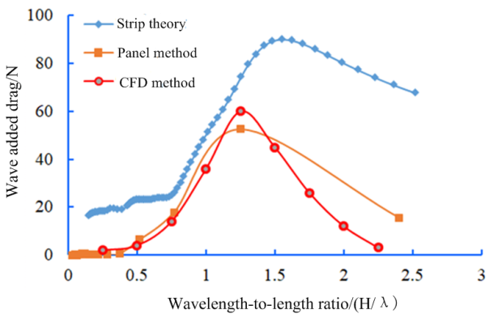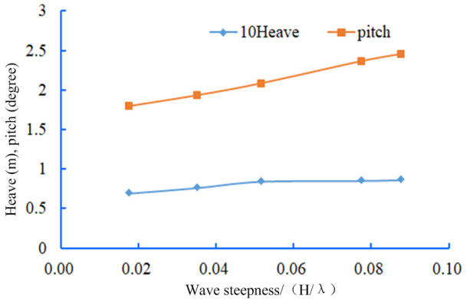

Fig 10. Wave resistance coefficient Fig 11. The heaving and pitching values of the fishing vessel under different wave steepness

**5.** **Conclusion**

Based on the CFD method, the commercial CFD software STAR-CCM+is used to study the resistance and motion response of high-speed fishing boats in waves. The first order Stokes wave numerical flume is established to simulate the wave resistance, heave and pitch motion response of fishing vessels under the condition of wavelength length ratio of 0.75 to 2.25. The shape of the Kelvin free surface wave system is reproduced, and the relationship and reason of the change of the hull surface shear stress are analyzed. Finally, the results of CFD numerical simulation are compared with those of strip theory and panel method, which shows that the CFD method has advantages in simulating ship motion and resistance.

**Reference**

[1]Zakerdoost.H,Ghassemi.H,Ghiasi.M.Ship Hull Form Optimization by Evolutionary Algorithm in Order to Diminish the Drag[J]. J Marine Sci,Appl.2013.(12):170-179.

[2]Serani A. Hybrid global/local optimization methods in simulation-based shape design [D]. Universit`a degli studi Roma Tre,2016.

[3] Zhao Feng, Li Shengzhong, Yang Lei. Review of research progress in ship form optimization design based on CFD [J]. Ship mechanics，2010, 14 (7):812 -821.

[3]Orihara H, Miyata H. Evaluation of added resistance in regular incident waves by computational fluid dynamics motion simulation using an overlapping grid system[J]. Journal of Marine Science and Technology, 2003, 8(2): 47-60.

[4]Carrica P M, Wulson R V, Noack R W et al. Ship motions using single-phase level set with dynamic overset grids[J]. Computers and Fluids, 2007,36(9): 1415-1433.

[5]Tezdogan T, Demirel Y K, Kellett P et al.Full-scale unsteady RANS CFD simulations of ship behaviour and performance in head seas due to slow steaming[J].Ocean Engineering,2015,97: 186 -206.

[6]Shen Zhi-Rong , Ye Hai-Xuan, Wan De-Cheng.URANS simulations of ship motion responses in long-crest irregular waves[J].Journal of Hydrodynamics, 2014,26(3):436-446.

[7] Zhao Invention, Gao Chengjun, Xia Qiong. Application of overlapping grids in ship CFD [J]. Ship mechanics，2011. 15(5): 332-341.

[8] Shi Bowen, Liu Zhengjiang, Wu Ming. Numerical simulation of top wave motion in irregular waves of ship model [J]. Ship mechanics，2014，18（8）：906-915.

[9]Lin P, Liu P L F. A numerical study of breaking waves in the surf zone[J]. Journal of fluid mechanics, 1998,24(3):239-264.

[10]sheng-long Zhang,Bao-ji Zhang,Tahsin TezdoganLe-ping Xu,Yu-yang Lai . Computational fluid dynamics based hull form optimization using approximation method, Engineering Applications of Computational Fluid Mechanics,2017,12(3): 1-8.

[11]Masoudian M，Pinho FT，Kim K，et al. A RANS model for heat transfer reduction in viscoelastic turbulent flow[J]. International Journal of Heat & Mass Transfer. 2016， 100：332-346.

[12]Claus, D., Simonsen, J.F. and Otzen, S.J.. EFD and CFD for KCS heaving and pitching in regular head Waves. Journal of Marine Science and Technology,2013,18:435–459.

[13]Sheng-long Zhang,Bao-ji Zhang,Tahsin TezdoganLe-ping Xu,Yu-yang Lai.Research on bulbous bow optimization based on the improved PSO algorithm, China Ocean Engineering, 2017,(33)4: 487- 494.

[14]Maki A, Umeda N, Renilson M, et al. Analytical formulae for predicting the surf-riding threshold for a ship in following seas[J]. Journal of Marine Science and Technology, 2010, 15(3): 218-229