ATTACHMENT
- LESSON PLAN
LESSON PLAN
School : SMP Negeri 18 Tangerang
Subject : Mathematics
Grade/ Semester : VII / 1
Year School : 2019 / 2020
Time Allocation : 2 Teaching and Learning Hours
(2 x 40 minutes)

- Basic Competencies
3.6 Explaining the linear equations and linear inequalities in one variable and its solution
4.6 Solving the problem related to linear equations and linear inequalities in one variable
- Competence Achievement Indicators
    - Modelling the algebra expressions using algebra tiles
    - Solving the linear equations in one variable by applying mathematical operations of addition, subtraction, multiplication or division using algebra tiles
    - Solving the linear equations in one variable by applying mathematical operations of addition, subtraction, multiplication or division without using algebra tiles

- Learning Objectives
By the end of this learning, students will be able to:
- Model the algebra expressions using algebra tiles
- Solve the linear equations in one variable by applying mathematical operations of addition, subtraction, multiplication or division using algebra tiles
- Solve the linear equations in one variable by applying mathematical operations of addition, subtraction, multiplication or division without using algebra tiles

- Materials
Linear equations in one variable:
1. Algebra expressions
2. Solving the linear equations in one variable by applying mathematical operations of addition, subtraction
3. Solving the linear equations in one variable by applying mathematical operations of multiplication or division
- Teaching and Learning Method
- Approach / strategy: Student centered learning
- Model: Cooperative learning
- Method: Group discussion, ask and answer, collaboration work, presentation
- Teaching and Learning Materials / Media
- Algebra tiles
- Worksheet
- Stationeries (pencil, paper, eraser, ruler, marker, glue, sellotape)

Teaching and Learning Resources
- Textbook: Mathematika SMP/ MTs Kelas VII Semester 1 Kurikulum 2013, Edisi Revisi 2016 (Mathematics textbook for 7 Grade Semester 1 of Junior High School, Curriculum 2013, Revision edition)
- Textbook: Buku Guru Mathematika SMP/ MTs Kelas VII Semester 1 Kurikulum 2013, Edisi Revisi 2017 (Mathematics teacher textbook for 7 Grade Semester 1 of Junior High School, Curriculum 2013, Revision edition)
- Internet: Lesson Plan 2: Cups and Chips – Solving Linear Equations Using Manipulatives; https://www.learner.org/series/insights-into-algebra-1-teaching-for-learning-2/variables-and-patterns-of-change/lesson-plan-2-cups-and-chips/

Instructional Procedures
Teacher’s Activity | Student’s Activity | Time
Opening
Greets to the students | Greets back to the teacher | 10 minutes
Ask one of the students to lead pray | Pray together
- Teacher explains the learning objectives and teaching and learning method | Students pay attention and get ready to learn
The students are divided into six groups | Students already seated according to their grup
Main Activity
- Teacher ask the prior knowledge related solving the linear equations in one variable, that are the integer and operations of addition, subtraction, multiplication or division  - Teacher ensures that students understand about mathematics operations in the integer by question and answer method | Students give answer | 7 minutes  Reviewing the previous lesson
- Teacher informs that the learning about linear equations in one variable implemented by using algebra tiles  - By discussing, teacher introduces the algebra expressions and linear equations in one variable  - Using the question and answer method, teacher explains how to solve the linear equations in one variable using the algebra tiles  - Teacher make sure that students understand the use of algebra tiles well  - Teacher gives the worksheet and the algebra tiles to all groups | - Students pay attention about the material introduced by teacher  - Students participate actively in asking and answering questions  - Students understand about the use of algebra tiles well | 13 minutes  Presenting the material and the use of algebra tiles
Teacher moves around and guides the students in each group:  - Observe the students as they work  - Give suggestions or help students who are having difficulties.  - Look for ‘good’ ideas with the intention of calling them in a certain order during discussion  - Encourage alternative method to solve the the linear equations in one variable | - Students discuss in group to do the task based on the worksheet  - Students model the algebra expressions using algebra tiles  - Students solve the linear equations in one variable using the algebra tiles  - Students solve the linear equations in one variable without use the algebra tiles | 20 minutes  Students working on their own
Teacher guides and lets students discuss among themselves | - Each group present their work on the board.  - Other groups give response by asking question or giving other solution. | 20 minutes  Whole-class discussion
Teacher asks the students about their answer in solving the linear equations in one variable by applying mathematical operations of addition, subtraction, multiplication or division  Make the conclusion | - Students explain the strategy of solving the linear equations in one variable.  - Students make conclusion about the algebra expressions and how to to solve the the linear equations in one variable | minutes  Highlighting and summarising the main point
Closing
- Teacher leads students to reflect on what they have learned.  - Teacher gives exercise. | - Students reflect on what they have learned | 5 minutes  Exercises

- Assessment
Assessment technique : Test
Question Form : Essay
Instrument : attached

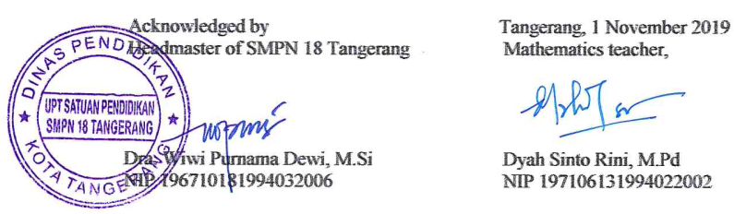

II. STUDENT WORKSHEET
STUDENT WORKSHEET
Subject : Mathematics
Grade / Semester : VII / 1
Material : Algebra
Student activities:
- Modelling the algebraic expressions using algebra tiles
- Solving the linear equations in one variable by applying mathematical operations of addition, subtraction, multiplication or division using algebra tiles
- Solving the linear equations in one variable by applying mathematical operations of addition, subtraction, multiplication or division without use algebra tiles

1. Modelling the algebraic expressions using algebra tiles

Model the following algebraic expressions using algebra tiles!
- 4x + 3
- 5a – 10
- x² – 3x + 5
- m + 7 = –6
- 3z + 5 = 14

2. Solving the linear equations in one variable by applying mathematical operations of addition, subtraction, multiplication or division using algebra tiles

Solve the following linear equations in one variable using algebra tiles!
- x + 3 = 8 5. 3m = 24
- 9 = m +1 6. 2x + 6 = 12
- 10 = n – 4 7. 3z + 5 = –16
- –5 + x = –1 8. 5x + 8 = 2x – 7

3. Solving the linear equations in one variable by applying mathematical operations of addition, subtraction, multiplication or division without use algebra tiles

Solve the linear equations in one variable below!
- 4 + x = 10 5. 4x = 12
- 11 = n – 2 6. 2y + 4 = 0
- a – 7 = 20 7. 14 = 2a + 4
- –2 = – m + 5 8. 6n – 1 = 2n + 19

- ASSESSMENT
ASSESSMENT
Subject : Mathematics
Grade / Semester : VII / 1
Material : Algebra

Solve the linear equations in one variable below!
- x + 6 = 10
- 8 = a – 1
- 4x + 4 = 0
- 3 + 2m = 15

- PRESENCE

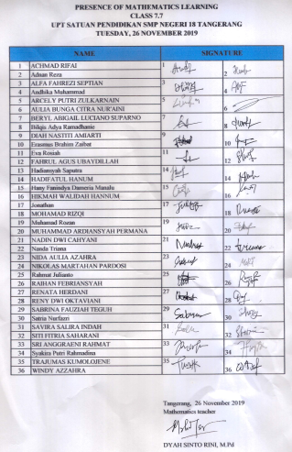

- SCHEDULE
Classroom implementation has been implemented based on the schedule of the mathematics learning in class VII.7 SMPN 18 Tangerang. The classroom implementation was carried out on Tuesday, 26 November 2019, from 12.20 to 1.40 pm at classroom of VII.7 SMPN 18 Tangerang.

