Tanoker Community as a Counter Culture Movement
To Communicate Traditional Games in Ledokombo Jember Indonesia

Juariyah
Department Communication, Faculty of Social Science, Universitas Muhammadiyah Jember, Indonesia
Email: juariyah@unmuhjember.ac.id

Putri Robiatul Adawiyah
Department Social Government, Universitas Muhammadiyah Jember, Indonesia
Email: putri.ra@unmuhjember.ac.id

ABSTRACT
Tanoker is one of the traditional games in Ledokombo Jember Indonesia which is one of the cultural heritages whose existence must be protected and preserved. The Tanoker community has begun to actively promote this traditional game to be introduced to the community. The purpose of this study is to examine the Tanoker community in their efforts to prevent the negative impact of online gaming culture through traditional games. This type of research using in this study is a qualitative approach with ethnographic methods was used in this study as well as by analyzing the text and interview results. The results showed that the Tanoker community played a role in communicating the traditional game of tanoker in the community as a counter culture movement to communicate traditional games in Ledokombo Jember Indonesia.
Keywords: Tanoker community, Communication Culture, Culture Movement, Video Games.

INTRODUCTION

When digital technology has entered all levels of societies’ lives in Indonesia, online games and video games have finally become a new form of addiction in society. Research, conducted by Winsen Sanditaria (2014), entitled Addiction to Playing Online Games in School Age Children, examines 62% of children who play online games are addicted, and as much as 38% are not addicted. One of the causes of addiction to play video games is because the interesting games presented with audio and visual effects that are displayed make players feel comfortable in front of the computer, based on a study entitled Audio and Visual Distractions and Implicit Brand Memory: A Study of Video Came Players by Yung Kyun Choi (2013), mentions that games that display audio and visual stimuli become interesting media, for example action video games require audio-visual processing quickly and respond faster. According to Detenberg, Simon and Benneu (1998) confirmed that visual stimuli such as motion in video games increase the level of physiological desire of gamers. Online advertising research shows similar results. Sundar and Kalyanaraman (2004) suggest that when Web advertising includes visual stimuli such as animation, viewers have higher levels of physiological desire. So, various visual stimuli in playing video games affect the desire and involvement of players with playing video games.
There are positive and negative impacts of this game, some studies show many negative effects of video game games (Tobias Greitemeyer, 2018), that exposure of violent video games has been shown to increase aggression on players, other studies show that video games offer positive and negative experiences in gamer’s life. Negative experiences mainly result from using video games as a strategy to deal with other life stressors. Secondly, influences of individual, interpersonal, and environmental play simultaneously to encourage and attract the number of game players (Jing Shi, Rebecca Reinwich, Nigel E. Turner, 2019). The popularity of playing video games has increased tremendously over the last decade. Approximately, half of Americans play video games on various electronic devices while 10% of those who play self-identify as a gamer (someone who consistently plays video games and identifies with the gaming community) (Pew Research Center, 2016). A number of studies have also found positive uses for video games (Ferguson, 2010), including reducing flashbacks from post-traumatic stress disorder (Holmes, James, Coode-Bate, & Deeprose, 2009), reducing chronic pain (Jones, Moore, & Choo, 2016), and training of health care professionals (Wang, De Maria, Goldberg, & Katz, 2016). Another research also mentions that video games have become an intimate aspect of the lives of many children in advance and developing countries (Berk, 2009; Abram and Luther, 2004; Parmentier and Rolland, 2009; De Prato and Simon, 2016; Basole and Karla, 2011). These studies illustrate that video games have become part of the gaming trend.
Referring to the game as an activity that occurs within the boundaries of space, time, and certain meaning according to definite rules, it will come to the conclusion that all branches of science and learning contain many forms of play because each of them is isolated in its own field, and it is limited by strict rules of its own methodology (Huizinga, 1938/1971, Homo Ludens). Playing/games can be interesting and fun, but it can also be challenging as the characteristic that the study of games has to offer. There are many ways in which games and the study of games are presented, some of them use the breadth and diversity of game itself, other parts because the disciplines used are new fields, and there are few certainly valid approaches to research games. This research is the main starting point for discussing games as a culture. Players are addicted to games because of the challenges, and play involves creating, testing and improving strategies and involves essential skills to the progress of the game.
The international academic community directs their energies towards understanding games not only because of their personal enthusiasm for games but also with the aim of learning important lessons about the forms of social life and creative practices that are taking place in late modern society. Games are the most successful example of information and communication technology becoming a domestic area which means that it is significantly integrated in everyday life and becomes the habit of several groups of people. In fact, there has been an academic study of games for a long time, particularly those disciplines such as history and ethnography. To point out two classic disciplines by the ethnographer, Steward Culin: Games of the North American Italian published in 1907, and a History of Chess by the Englishman Harold James Ruthven Murray in 1913. A history of research in the systematic design of games for the purposes of learning can be traced back to certain tactics and strategies from German work in the eighteenth century. Helwig the Duke of Brunswick master turned chess into an early war game in 1780; he also writes about the purpose of game design to create 'recreation, art and military. (Avedon and Sutton-Smith, 1971: 272)
Then, different varieties of war games were developed and discussed, both from a military point of view and in an entertainment context. The group of American gamers formed in the 1950s was the East Coast War Games Council, an organization that organized a series of symposiums and published proceedings including presentations from those meetings in the 1960s. Following the expansion happened, the name of the group was changed to the National Gaming Council for the first time. Because the public was interested in using games, especially simulation games, to expand learning, the group's name was changed to a new name – the North American Simulation and Gaming Association (NASAGA). In other countries, similar developments have occurred, and the research and simulation games community have expanded into an international network of national networks. As an umbrella organization, the International Simulation and Games Association (ISAGA) was formed in 1970 and has held more than thirty annual conferences since it involves researchers who focus on games and simulations and their uses for various applied purposes. An academic journal, Simulation & Gaming has been published since 1970 making this journal as the oldest regularly published journal in this field (Duke, 2003; Knuth, 1994).
Another group of South American scholars joined together in Minneapolis for the first time in 1973 and formed an association focused on the study of games in 1974. Changing its name to The Association for the Study of Play (TASP) in 1987, the group published proceedings from its annual meeting since then. (The group's original name was the 'Cultural Anthropology of Play Reprint Society'.) A series of journals published by this association became an important venue for the development and publication of game research: Play and Culture (1988 – 1992), Journal of Play Theory and Research (1993). – 1997), and the most recent one, Play and Culture Studies (1998 –) (Myers, 2006; TASP, nd).
There are several types of game studies that are mostly significant ones in the field of game behaviour research which is the branch of computer science that studies graphics, simulation and artificial intelligence, and computational humanities. It is clear that the contemporary wave of game studies takes the last field of the existing fields to start its research. Old thinkers such as Vannevar Bush in the 1940s had already discussed his notion of dealing with tools or means that could operate in the same associative way of human thought rather than form based on strictly linear categories. Theodore Nelson gave the name 'hypertext' to written or illustrated connected material that is easily presented or represented on paper (Nelson, 1965/2003: 144). Advances of human interaction with computers and the increasing availability of computers either for being used by the general public or individuals who play an important role as humanities practitioners and scholars begin to conduct research on the potential and implications of this new technology.
Another study conducted on video games in rural areas, precisely in Ledokombo, was conducted by Triono Akmad Munib et al. (2011) His research was entitled Modern Games vs. Traditional Games for Tanoker Community in Ledokombo, Jember Regency. The research data show that Ledokombo is one of the areas affected by the globalization of modern games. This can be seen with the expansion of internet and PS rental businesses in Ledokombo. Children often go out without saying goodbye to PS rentals and often forget time to study and recite the Qur’an. Around 30 percent of the children in Ledokombo have not played in PS rentals, and if parents see their children not at home, they go straight to the Tanoker headquarters and they are playing stilts. The results of the study illustrate that only 30 percent decreased. This figure is still very small, which means that many children in Ledokombo District still like video games.
Another study on Tanoker Community in Ledokombo was conducted by Velayati (2014) entitled Tanoker Ledokombo Community: A Supporter of Rural Social Change Through a Cultural Approach. This study examines the learning and playing community of Tanoker Ledokombo as agents that encourages rural social change through a cultural approach, how the process of transferring cultural values ​​as a form of cultural approach that Tanoker applies in daily life. The conducted activities aim to develop the potential of children at the elementary and junior high school levels which are divided into seven clusters, which are reading and writing, traditional games, cooking, sports, music, dancing and painting. Through the seven clusters, the guards innovate a mentoring by using a cultural approach. The result of this research is that Tanoker Ledokombo encourages rural social change through a cultural approach by carrying out mentoring activities with traditional stilt game media as well as singing accompanied by musical instruments which are then sharpened to discuss certain themes in daily life.
This study aims to gain a more holistic understanding of the picture of video games in the village, the opinion of parents about video games, and a group or community that wants to minimize children who play video games with other games that are more interesting by showing traditional game. Since 2009, this community has been actively gathering children regularly to play and learn, the goal is to reduce playing video games. Several games are offered regularly to children and adolescents with the aim of fostering a cooperative, discipline, and sportive sense. This activity is such a counter against video games, and it has been consistently carried out by the Tanoker community for a decade.

LITERATURE REVIEW

Game: Local and Modern Negotiation
Culturally, humans basically have a desire to play (Huizinga, 1990). Through games, people express the interpretation of life and the world (Huizinga, 1950/1938:46). Play is very close in human life for children, adults, and parents. Research conducted in America shows that data on adolescents and children show games that use handheld devices and games (Zackariasson, 2012). Research conducted by Fu-Hsing Tsai, Kuang-Chao Yu and Hsien Sheng Hsiao (2011), explains that playing is a common experience for all humans, including children and adults. In recent decades, a large number of researches (Csikszentmihalyi, 1990; Provost, 1990; Yawkey & Pellegrini, 1984) in anthropology, psychology, and education have stated that play is an important mediator of social learning for children and adults in their lives. Kerr and Apter (1991) claim that games are an appropriate and desirable way of describing meaningful learning. But playing digital games has become a very favourite game. Research conducted by Tobias Greitemeyer concluded that video game exposure differs from other forms of media exposure and people directly controlling game characters, which enhance media content (Fischer, Kastenmuller, & Greitemeyer, 2010; Konijn, Bijvank, & Bushman, 2007), playing video games cause a stronger effect than passive media exposure. Because this self is really involved by requiring the player to take control of the game character and the player's identification.
Space Fortress wrote a review of study about video games that the first video game created in the 80s is to analyse cognitive processes (Mané & Donchin, 1989). The game looks like an arcade game from the data of a video gamer from the 21st century. In its development, this game has become a large industry, indicated by the global video game market continues to grow and is expected to reach US $ 150 billion in 2019 (Kooistra, 2019). Therefore, the video game industry has long surpassed the US$40 billion film industry (McClintock, 2017) and it is roughly equal to the global sports industry (Taylor, 2017). This game also affects both men and women, according to research by Brown et al. (1997) found that men outperformed women in Pong but both sexes showed significant performance improvements in the course of the study. Recently, Ratan and colleagues (2015) surveyed more than 18,000 League of Legends players. They used a skill measure designed by game developers and reported that men, on average, had significantly higher skill levels than women.
Uno Tsunehiro (2008, 13) states a split between “old imaginative forces” (furui sozoryoku) and “contemporary imaginative forces” in Japanese pop culture narratives (gendai no sozoryoku). This "old imaginative power" was widespread between 1995 and 2001, and it can be found in representative works from that period, such as Anno Hideaki's Evangelion Neon Genesis (1995-96). These narratives refer to the social and political climate of 1990s in Japan, which portrayed the bursting of a bubble economy and domestic terrorism from Tokyo subway gas attack in 1995 (14). As a result, Uno argues that these works reflect the general sense of powerlessness felt by Japanese people. In particular, the agency of individual characters, or the ability to "do" or "do not" something (suru/shinai), is replaced in this mid-1990s narrative with a forced worldview where seemingly intractable situations are beyond anyone's control. ("it is "or" it is not "—dearu / dewaai; 18) Napier (1993, 334) identified a similar trend even earlier, stating that Komatsu Sakyo's 1973 science novel Nippon Chinbotsu (Japan Sinks), in where Japan was devastated by multiple disasters, could be read as a "safe horror" genre, but the film's action and ending are bleak, emphasizing the loss of success. Napier suggests that the 1973 film adaptation of Nippon Chinbotsu allowed listeners to feel the grief of mourning due to the death of traditional Japanese society.
Video games using the Wii Fit balance platform have been used for balance rehabilitation in a number of settings. The use of technology, particularly when implemented outside of a hospital setting, provides many advantages for individual patients and the NHS completely. The findings of this trial study add many evidences regarding the role of video game technology in improving the health and quality of individual’s life with dizziness and balance disorders. Implementation of cross-board video games for all types of patients will be considered a beneficial treatment modality, with all forms of vestibular disorders, would not be appropriate; but when given carefully to selected patients that requiring general vestibular rehabilitation for prescribed vestibular loss, with enthusiasm to engage in such a process. The findings of this trial study, and in particular its limitations, will provide great insight for larger-scale planning of studies in the future which investigate the use of video games to improve the rehabilitation of balance-disordered patients. Another form is used in libraries, video games in libraries to support the goals of education, recreation, and democratization of institutions. Design/methodology/approach - Traditional models checking of library understanding and how video games fit into images. Findings of video games are goals to support library, education, recreation and democracy. Jenkins et al. (2006) do, that video games do not reduce the need for traditional texts.
Many games require players to read messages and players must communicate via online text chat. Not only reading within the game room itself, but also players reach out online sources such as official and unofficial websites, or other sources such as manuals to succeed in the game situations. In addition, Squire and Steinkuehler (2005) report that, 'Every time we meet with students, we ask who have checked books from the library based on the resulted interest through play. Half of them said yes. In fact, most of each student we meet have played Age of Empires, Civilization, or Rome: Total War has checked out books about related topics.
In addition, there is a lot of learning, reflection, problem solving, meaning making and information searching that takes place in virtual playrooms (Johnson-Eilola, 1998). The ability to cope with multiple information spaces is important in conventional information literacy efforts. It is also important in the game or in the real world for information literacy to contextualize the need in terms of applicability and authenticity. It is important for us to understand that there are similarities between game culture and the need and use of real-life information. Squire and Steinkuehler (2005) point out that, one of the internal competencies in the gaming community is the ability to negotiate several competing information spaces spanning various official/unofficial media and channels. Assessing the quality of information does not just come down to ascertain what is legal and what is not: it involves understanding what the information will be used for, its strengths and weaknesses in terms of reliability and the types of valid conclusions that can be drawn from it.
So, it is clear, despite concerns that games are replacing literacy activities, there are elements of play that strengthen traditional literacy that is so important in libraries, and in life. Games also extend to new literacy which is equally important in the world now. Adults often misunderstand what really happens when children play, with and around their favourite video games. To achieve the things that they do with respect to their games, young people have to think not only about digital, but also how different strategies work and how games relate to other things like books, movies, politics - in short, the real world. When played proactively, as Gee (2003) argues, most of the time, games do not only mean playing and learning, but players also can develop a variety of digital and media literacy.
The theory of self-expression of play is compiled by Elmer Mitchell and Bernard Mason. This theory states that humans play in response to the basic needs for achievement and creativity. Another similar theory is implied in Abraham Maslow's famous hierarchy of needs. According to this psychologist, the highest human need is self-actualization. This means that humans have a basic need to be creative and play, because creative behaviour is artistically and aesthetically a way to fulfil self-actualization. As Miller and Robinson conclude from the aesthetic theory of play, this theory emphasizes that the function of play is to bring beauty into human life with the aim of encouraging creativity for self-actualization.

METHODS

This research was conducted in Ledokombo Jember Indonesia considering from the results of previous research that Jember is one of the areas affected by the globalization of modern games, this is marked by the increasing number of children playing video games and the disappearing of traditional games. Tanoker Community since 2009 has inspired the counter culture movement by minimizing playing video games, which is the Happy Sunday (Minggu Ceria) activity initiated by the Tanoker Community. This type of research using in this study is a qualitative approach with ethnographic methods. This method is to describe, interpret and understand the characteristics of social settings with symptoms of various cultures and their various interpretations or expressions and adopt an emic approach, which means that researchers interpret data from the perspective of people in the cultural setting studied (Flick Uwe etc 2004:224). Interviews were conducted deeply with video game players in the village, their first experiences with modern video games, and using these video games as a media to fill their spare time. There are 3 (three) interviews with children or players. Interviews were also conducted with parents having children who like video games. The reasons why parents buy game sets and let their children enjoy these modern games. They were 4 (four) people being participants in this interview.
Data analysis conducted is using qualitative analysis.
The plot of data analysis techniques can be seen below.

Figure.1 Plot Analysis Technique Source: (Sugiyono, 2017:247)

Based on the picture above, the research steps are as follows:
- Collecting data (Data Collection), or also called collecting data in other words which includes observing, interviewing and collecting documents.
- Reduction, which summarizes and selects the answers to the main answers related to the research, so it clearly describes and makes it easier for researchers in the next process.
- Display, in this study presents data, so it is easy to understand that the data is organized.
- Verification in this study, if the initial conclusions are still temporary, there will be changes that are supported by valid evidence so that they can be trusted.

RESULTS AND DISCUSSION

Video Games in the village
Many village communities are getting to know video games with the inclusion of internet network facilities in the village or from village programs. This has led to the introduction of game play both from PC computers and laptops as well as Android phones which are currently starting to be affordable. Playing video games is becoming a popular game today. This game makes people open rental businesses in their homes, one of them is in Ledokombo, Jember, Indonesia. Playing video games becomes a very interesting game every day, and they spend hours playing this modern game. The room is cramped, humid, but it does not matter when you are busy playing.
The Tanoker community is a community that cares about introducing the culture of the traditional game of tanoker to the Ledokombo community. This community plays a major role in the cultural movement, and has community awareness and responsibility to preserve the existing cultural diversity, especially now that many young people are starting to not know traditional games and are very interested in online video games. Whereas youth in inheriting local culture are expected to be a force for the existence of local culture itself.
According to previous research by Fitria Fitria, 2018; found that traditional invention games have positive values, including encouraging honesty, responsibility towards oneself and others, a healthy lifestyle, discipline, hard work, fun, logical and critical thinking skills, creativity and innovation, compliance with rules, respect. for another. duties and achievements, democracy, empathy, concern for the social environment, nationalism, development of social aspects, and respect for differences. On the other hand, traditional games can also develop aspects of friendship, self-management, and academic behavior and reduce antisocial behavior. In contrast to online games that tend to make children addicted, irritable, self-control and self-control and time discipline.
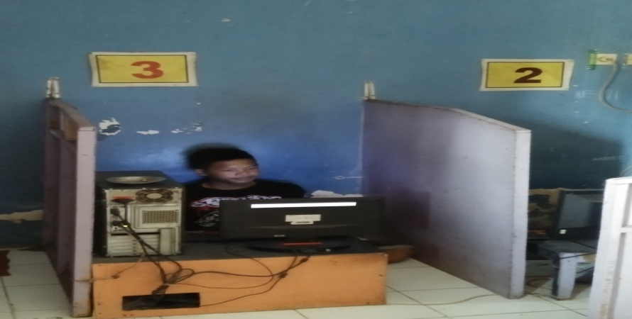
Figure 2. Playing Video game in rental business
In the image, we can see a child playing video games in a rental business house.
FA’s opinion (13 years old) as follows:
“...My experience playing video games for the first time was when I was in elementary school. My friend invites me to play at that time known as the Playstation (PS 1). I feel very happy because it is a gift after circumcision, playing these video games to fill spare time, and making friends, the games mostly played are adventure games, marketing and smack force”.

FH has been playing video games since he was in elementary school until he still continues playing video games. Chin-Sheng, Wan: Bin Chiow's research entitled The Motivation of Adolescent Who Are Addicted to Online Game. stated that this research conducted in Taiwan used the theory of Cognitive Perspective on adolescents in Taiwan who are addicted to online games. His findings explain that addicts show higher intrinsic motivation than nonaddicts, so intrinsic motivation plays an important role in games and extrinsic rewards will undermine intrinsic motivation. Furthermore, it is mentioned that the popularity of the internet greatly affects and infiltrates many aspects of human life, although it brings various kinds of convenience, some negative aspects will gradually emerge, such as internet addiction. Intrinsic motivation comes from within us to do something because we enjoy doing it. While extrinsic motivators come from outside, we do something because there is a reward or punishment. When people play games, they can derive extrinsic motivators such as praise from others, money, or prizes and fame. Meanwhile the intrinsic motivators are curiosity and exploration, ownership, autonomy, competence, and goals/plans.
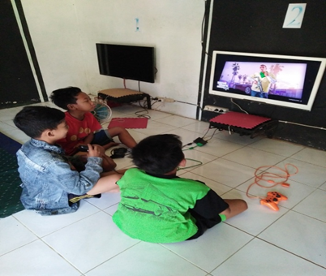
Figure 3. Always playing video game together in village

Playing video games in their village do it together. Unlike those in urban areas. This shows togetherness, still awake and they play alternately.
Another experience presented by Adt, (13 years old), as follows:
“The experience of playing video games was invited by friends at that time, the type of game was ball games/CTR, it was nice to be at this cyber cafe, there were many friends so it became a very favourite place, it was very fun to play with friends than playing alone, because it became my hobby. Finally, I worked in this internet cafe as the owner from a hobby to a business opportunity, my parents never forbade me to play games as long as I remember the time, the most memorable experience is that when I was a child, I was so happy playing video games. I once permitted to go to lessons but actually I went to play games. I do not like games that contain violence like MOBA, other sites that are opened when playing games are usually cartoon sites."
Research conducted by Kimberly D. Thomas (2010) entitled Does the Endorsement of Traditional Masculinity Ideology Moderate the Relationship Between Exposure to Violent Video games and Aggression? stated that current video games are very interesting and interactive (Gentile & Anderson, 2003) placing a player in a first-person perspective, who must make a decision to commit violent acts before committing other acts. These games demand rewards and anti-social behaviour (Gentile & Anderson, 2003). For example, in one of the games “Grant Theft Auto” the player steals a car, visits a strip club and commits suicide. Doing a crime makes players receiving more opportunities to do other crimes, and none is realistically punished (Fleming & Rickwood, 2001). These video games have an adverse effect on players (Anderson & Dill, 2000), for example, there will cause high individuality and low conformity and indifference as detrimental effects of violent video games (Markey & Markey, 2010).
According to Anderson (2010), the effects of short-term exposure, such as playing violent video games for 15 minutes, markedly increased aggressive thoughts and emotions. Increased desire, and several times immediately imitate aggressive behaviour. While the effects of long-term exposure (video game replay) include personality changes, beliefs that aggression is an acceptable way to deal with problems, increased availability of aggressive behaviour, and reduced access to non-aggressive behaviour. Furthermore, in this study it was stated that boys tend to play video games more than girls. And the choice of games tends to be tougher (Moller & Krahe, 2009). Violence in video games does not make boys more violent, and girls more sensitive towards violence (Deselms & Altman, 2003). The conclusion of a study conducted by Kimberly D. Thomas, is that while some individuals may be more at risk for the potential negative effects, people who strongly support traditional masculine norms have the strongest association between video game exposure and violent aggression. Parents should monitor or limit their child's play, if their son probably support traditional masculine norms strongly.

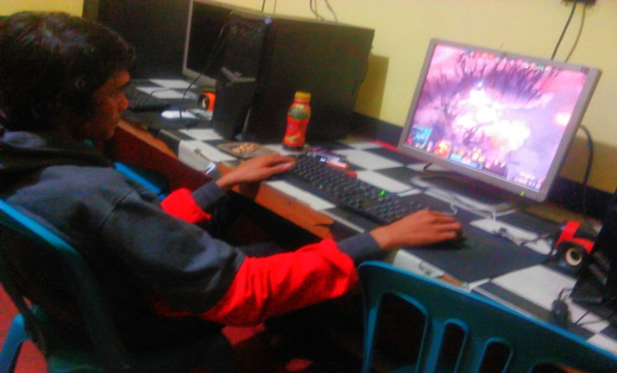
Figure 4. Playing in City

Playing in an urban environment is very different with a village. In the city, playing alone and the atmosphere in the room is better than the village. They connect with their rivals in all corners of the world, players sink in a challenging game which is usually fun.
As MH's experience (14 years) below:
"Besides playing video games, my hobby is playing sports just to fill my spare time, initially I knew these video games when I was in elementary school, until now I still enjoy playing this game, there was once a ban from my parents because my grades dropped when I was still in junior high school and realized, if I lie for this game, I use middle school and high school tuition money to buy war equipment such as swords like in games, the type of game that you like the most is when you are little, you are happy with GTA, Naruto, Dragon Ball, after getting big, you are happy with Dota 2, adventure and strategy. For the experience of exploring games, usually games where the characters have challenges and complexities.”

Several types of games have their own characteristics such as types of sports games, for example Madden NFL (Tiburon, 2011), that allows players to play simulations of various athletic sports. These games typically require players to manage multiple characters and often played in a multiplayer mode with multiple players controlling different teams, to stimulate a racing experience and to allow players controlling vehicles and race against other players to reach the finish line. Flight games simulate the experience of flying by allowing the player to control an airplane, spaceship or other flying machine.
This type of Fighting game has the characteristic of requiring the player to fight his way through the enemies on their way to the final destination. A fighting game like Street Fighter IV requires the player to push the button to perform various attacks against the rival. It is the skill of pressing these keys that determines the success of this game which means the game depends on mastering the sequence of keystrokes and their timing. Besides Fighting, another type is Shooters, which is a type of game that requires players to shoot. In contrast to fighting games where players use hand to hand weapons with swords or sticks, the intended shooter is a sub-genre of first-person shooter and third-person shooter. First-person plays with the character's visual perspective, such as the player looking into the game world through the character's eyes, third-person giving the battlefield and requiring the other players who aim to two-dimensional (up/down and left/right) directions with an indoor first-person shooter in three dimensions.
Adventure games, different with communal, are a type of game that depicts people as players who control characters in adventures. In this game, the player is faced with a goal or quest on the way or completing the final goal. This game emphasizes the exploration of the open game world. Action games are a type of game that requires the player to take on the role of a protagonist and guide through a series of physical challenges. Action games are usually organized into difficulty levels, and the player must complete them in order to reach the final goal. Usually in this action, game has a "boss" or more difficult enemies. When the player can complete the level, and then the player will level up. Usually, adventure games have an action game aspect and vice versa, and then an action/adventure genre game appears. The player controls a character who sets out on an adventure, overcoming obstacles on the way to the final destination and several forms of combat. Another type is RPG (Role Playing Game). The emphasis in RPG games is on the player completing quests, and levelling up, in this game there are attributes such as strength, protection, stamina and health points which are set at certain values ​​at the start of the game. If getting progress in the game, the player gains "experience points" through completing quests and defeating enemies. And once the player reaches the pointed number, then achieve the "level up" or high level and get a permanent increase in the attributes of this RPG game.
In RPG games, levelling up is the main motivation, some RPGs even ask players to engage in what is known as “level grinding” which takes a long time to do and fight enemies for the purpose of levelling up. Most players think that what makes RPGs different with other games is that they have a complicated storyline that involves a large number of players in character dialogue form.
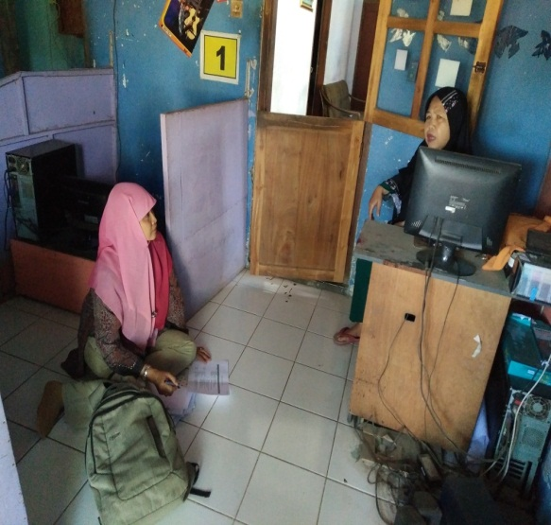
Figure 5. Interview with parent

GN’s (33 years) experience of playing traditional games is as follows:
“I am a girl, when I was a kid, I used to play rubber, bekel, hide and seek, cook, crank, slodoran /gobak sodor, etc., my house is close the field, so it was always crowded. I think the games of my era make us healthier than the games of my children’s era because they moved more. Now, I see my child playing video games, he never moves from his seat, it is not healthy. Even though I have a Playstation 2 at home, I cannot play it and I am not interested either. So, it was better and happier when I was little than now.”
Figure 6. Interview with parent

The opinion of parents in deciding to buy a video game device is usually as a gift to go to class or in order to keep the child at home, so he is under the watch. Another opinion of parents was expressed by Mrs. YN (35 years old) who stated that:
“I decided to buy a video game for my child, because by playing video games at home I can watch my child's playing. That means I know what kind of games he plays, and I can also decide or tell my child to stop playing or when the time he can play video games”

There is another reason stated by Mrs. SN (30 years):
““I bought it for a child as a gift for a class promotion, after all video games have become a modern game and all children know that if you do not buy them, they will be missing out and other technologies. Unlike me, I used to play with traditional toys like congklak, bekel, jump rope, hide and seek. The important thing is that children do not forget to study even though they often play…”

Based on some of the descriptions above, video games as a variant of the game today are more available and are mushrooming as a form of technology and era advancement. The thing that needs to be addressed is wisely is that determine the games by parents and children who play these video games. The development of information technology is very rapid. It is no longer limited to changes per day, but now it is faster in seconds. Children who are thirsty for knowledge, are relatively easier to accept the development of these technologies. Parental guidance is needed to introduce and teach children to filter out negative things that may be caused. Many parents mistakenly think that video games are just cartoon games that are funny and to entertain children, but in fact there are some negative elements that contain for children.
Besides having benefits, video games and computer games also have a negative impact. Parental involvement is needed to prevent children from taking advantage of this magic box. Mrs. Santi feels lucky that her children are 'friendly' with computers from an early age. EK (9 years old), her first child, not only enjoys playing games, but he also fluently operates various word and number processing programs. Meanwhile, his younger brother, ND (4 years old) who is just learning about computers, is already busy trying out educational programs in recognizing colours and shapes. Fatih is now good at math because he often practices with computer help. Meanwhile, Nadia has a lot of English vocabulary because she often plays computer.
However, Mrs. NY actually feels that she has a problem with her child's 'familiarity' with computers and video games. According to her, RK (7 years) now prefers to 'play' with his computer than with his friends. Rizki can spend hours just playing games. He is also lazy when his mom asks him to write or draw. Not surprisingly, the task of drawing at school was never done completely. However, he is very good to draw on the computer. Understandably, he can draw and colour perfectly with just one or two clicks.

Traditional Game Tanoker
The motto of Tanoker, which is to be friendly, to have fun, to learn, and to work, ‘friendly’ theme gives us an understanding that the Tanoker Community always prioritizes friendship with anyone regardless of background, ethnicity, race and so on, and having fun is the right of the children. The Tanoker community always wants to learn and to share knowledge and experience, learning makes changes for the better, and then working. This community grows and develops with innovative works that give benefit for the surrounding environment. The cultural theme is a reference in encouraging rural social change in Ledokombo District. Starting from the traditional game of stilts, Tanoker which was established on December 10, 2009 and located about 15 meters after the three intersection monuments in Ledokombo Village, became an interesting place for various scientific studies. From that name, they aspire to develop from a cocoon which is considered ugly and disgusting, but it turns out after metamorphosed, it can become a butterfly with a charming colour, and it can fly everywhere, so many people will like it. The deeper they interpret the name, the more eager they want to carry out activities as evidence that even though they are part of the village children, their creativity does not want to be outdone by the children in the city. They want to realize and intend to perform in various areas, especially with the game of stilts.
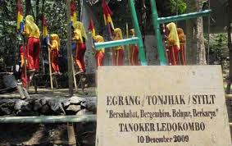
Figure 7. The Tanoker Inscription which was established 13 years

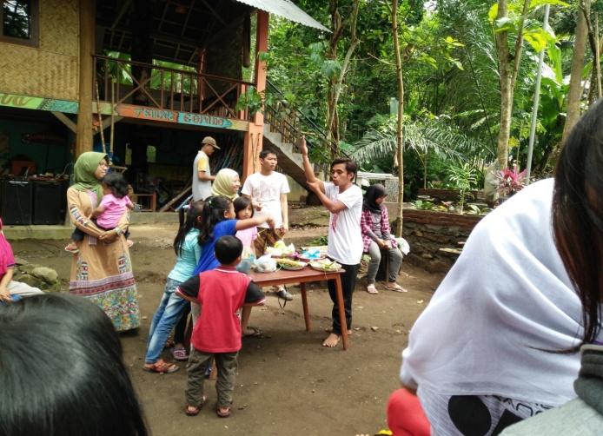
Figure 8. Happy Sunday Activity with the theme of cooking

Being involved in the “Happy Sunday” activity organized by the Tanoker Community, every Sunday is a very pleasant thing. It begins with gymnastics along with an upbeat song instrument. After participating in gymnastics together, then following routine activities such as competitions, cooking, reading books, and so on. In the picture above, a Tanoker Community volunteer explains that this routine activity was originally formed by seven activity forums consisting of reading and writing, playing traditional games, cooking, doing sports, singing a song, listening to music, dancing, and painting.
The Tanoker Community is one of many learning communities in Indonesia, a place that seeks to develop the potential and character of children and the community through various creative activities that start with stilts. Stilt games except from bamboo are also made of iron, using this game requires practice. Learning to play stilts is not easy, and requires hard work. Likely Tanoker, it is built with hard struggles until the playground at Tanoker becomes a very valuable place for children to be able to express themselves freely through various traditional games to develop themselves. In the Happy Sunday activity, even though it is not written that it is not allowed to bring cell phones, in fact there are some children carry them. They only use their cell phones during break time. When the activity starts, it is prohibited to use cell phones. Suporaharjo states this rule as he wants to make these children able to communicate with friends humanely, and children can enjoy their right to live happily. This community is a play and learning community initiated by Mrs. Dra. Ciciek Fardah, M.Si and Mr. Dr. Suporahardjo, established on December 10, 2009. Located in Ledokombo Village, Ledokombo District, Jember Regency. The word Tanoker comes from the Madurese language which means "cocoon". The philosophy behind this choice of words is the belief that tourism based on cultural communities can encourage social transformation that can lift people from problems of education, health, and poverty. Given that many social problems that occur in Ledokombo, Tanoker aims to contribute solving problems, especially preparing children to live healthy, being smart and having prosperous lives.
Tanoker has a special concern for children. For Tanoker, children must live happily without neglecting the importance of personal development to become a virtuous human being and have an impact on society, nation and state. That is why this learning and playing community named "Tanoker". Tanoker Ledokombo becomes a community to play and learn, how to play as a culture is the approach to the beginning of this community's activities. The first traditional stilt play was introduced to children around Ledokombo Village, which at that time it was booming modern games, which are video games. The Tanoker Ledokombo community is not anti-modern games, some of them who come with cell phones, there are only rules when activities are being carried out, their cell phones cannot be used. This is where good values are internalized in children which will become provisions in their future lives.

CONCLUSION

The Tanoker Community as a counter cultural movement to communicate traditional games in Indonesia, it is done through Tanoker traditional game as one of the traditional games in Indonesia in Ledokombo Jember. The Tanoker community has started to actively promote this traditional game to be introduced to the public. Tanoker Community in an effort to prevent the negative impact of online gaming culture through traditional games. The results showed that the Tanoker community played a role in communicating the traditional game of tanoker in the community as a counter culture movement to communicate traditional games in Ledokombo Jember Indonesia. The Tanoker community is a community that cares about introducing the culture of the traditional game of tanoker to the Ledokombo community. This community plays a major role in the cultural movement, and has community awareness and responsibility to preserve the existing cultural diversity, especially now that many young people are starting to not know traditional games and are very interested in online video games. So that through the tanoker community, it is that it can be realized.

REFERENCES

Ahlstrom, M.,Lundberg, N. R., 2012. Me, My Spouse, And My Avatar: The Relationship between Marital Satisfaction and Playing Massively Multiplayer Online Role-Playing Games (MMORPGs), Journal of Leisure Research, 44(1), 1+ Retrieved from http://go.galegroup.com/psi/i.do?
Alverson, B. 2016. Game Changers:Books Based on Video games and Their Characters Have Broad Appeal, School Library Journal, 6(11), 30+Retrieved from http://go.galegroup.com/psi/i.do?
Becket-Olsen, K.L.,& Norberg, P.A, 2010. Caution, Animated Violence:Assessing The Effficacy of Violent Video games Ratings. Journal of Advertising. Retrieved from http://go.galegroup.com./psi/i.do
Castells, M. 1996. Rise of the Network Society : The Information Age: Economy,Society and Culture, Oxford, Wiley – Blackweell.,
__________. 1997. The Power of Identity, dalam The Information Age, Vol.2 – 97, Blachwell, Oxford
Chen, K., Chen, & Ross, 2010. Antecedents of Online Game Dependency: The Implications of Multimedia Realism and Uses and Gratifications Theory. Journal of Database Management, 21(2), 69+ Retrieved from http://go.galegroup.com/psi/i.do
Choi, Y.K.,Lee, S,M.,& Li,H. 2013. Audio and Visual Distraction and Implicit Brand Memory: Astudy of Video games Players, Journal of Advertising, 42(2-3) Retrieved from http://go.galegroup.com/psi/i.do?
Cohen, Roland, 1961. The Success That Failed: An Experiment in Culture Change in Africa, Anthropologica 3 – 1961 pp 21 – 36. .
Dovey, Jon & Kennedy, Helen W. (2006). Game Cultures: Computer Games as New Media. Berkshire: Open University Press.
Fitria, F. (2018). Development of motorized stimulation models based on traditional Gobak sodor game. 249 (Secret), 87–90.Gangadharbatla, H., Bradley, S.,& Wise,W. 2013. Psychophysiological Responses to Background Brand Placements in Video games, Journal of Advertising, 422(2-3) 251 Retrieved from http://go.galegroup.com/psi/i.do?

Mandoki, Katya, 2007. Everyday Aesthetics Prosaics, The Play of Culture and Social Identities, USA, Ashgate Publisging Company.

Matteson, A.2017. Build Games with Bloxels: with Cheery Blocks, Kids can Design Their Own Video games, Coding not Required. School Library Journal, 63(5)+Retrieved from http://go.galegroup.com/psi/i,di?

Mayra, Frans. (2008). An Introduction to Game Studies. London: Sage.

Paul, Christopher A, 2012. Wordplay and the Discourse of Video games. London & New York : Routledge

Sheremeta, R.M.,& Zhang, J. 2014. Three-Player Trust Game with Insider Communication. Economic Inquiry, 52(2), 57, 576+ Retrieved from . http://go.galegroup.com/psi/i.do?

Shi, W., Corrieveau, & Agar J. 2014. Dead Reckoning Using Play Pattens in A Simple 2D, International Journal of Computer Games Technology. Retrieved from http://go.galegroup.com/psi/i.do?

Sutarto, Ayu, 2002. Menjinakkan Globalisasi. Jember: Kompyawisda Jawa Timur.
__________, 2010. Permainan Tradisional sebagai Sarana untuk Memperkokoh Jati Diri Bangsa. Makalah dalam Sarasehan Pesta Permainan Tradisional Anak Nusantara

Terlutter, R,.& Capella, M.L. 2013. The Gamification of Advertising: Analysis and Research Directions of in-Game Advertising, Advergames, and Advertising in Sosial Network Games, Journal of Advertising, 42 (2-3),95+ Retrieved from http://go.galegroup.com/psi/i.do?

Thomas, K.D.,& Levant, R.F, 2012. Does The Endorsement of Tradisional Masculinity Ideology Moderate The Relationship Between Exposure To Violent Video gamesand Aggression? The Jounal of Men’s Studies, Retrieved from http://go.galegroup.com/psi/i.do?

Zulkarnain, I. 2014. Playnable Nationalism: Nusantara Online and The Gamic Reconstructions of National History, Sojourn: Journal of Social Issues in Southeast Asia, 29 (1), 31+ Retrieved from http://go.galegroup.com/psi/i.do?

