Table 1. Chemotherapy regimens on Turkish Pediatric Oncology Group Neuroblastoma 2003.¹

Chemotherapy | Drugs | Schedule
Induction cycles  A3 – 1 cycle  15-19 July 2019 | Vincristine | 1.5 mg/m²/day, D 1 and 5,  IV push
 | Ifosfamide | 1.8 g/m²/day,  D 1-5, IV continue infusion
 | Dacarbazine | 250 mg/m²/day,  D 1-5, IV 30 min
 | Adriamycin | 20 mg/m²/day,  D 1-3, IV over 4 h
A5 – 1 cycle  15-19 August 2019 | Cisplatin | 30 mg/m²/day,  D 1-5, IV continue infusion
 | Cyclophosphamide | 300 mg/m²/day,  D 1-5, IV over 1 h
 | Etoposide | 150 mg/m²/day,  D 4 and 5, IV 1 h

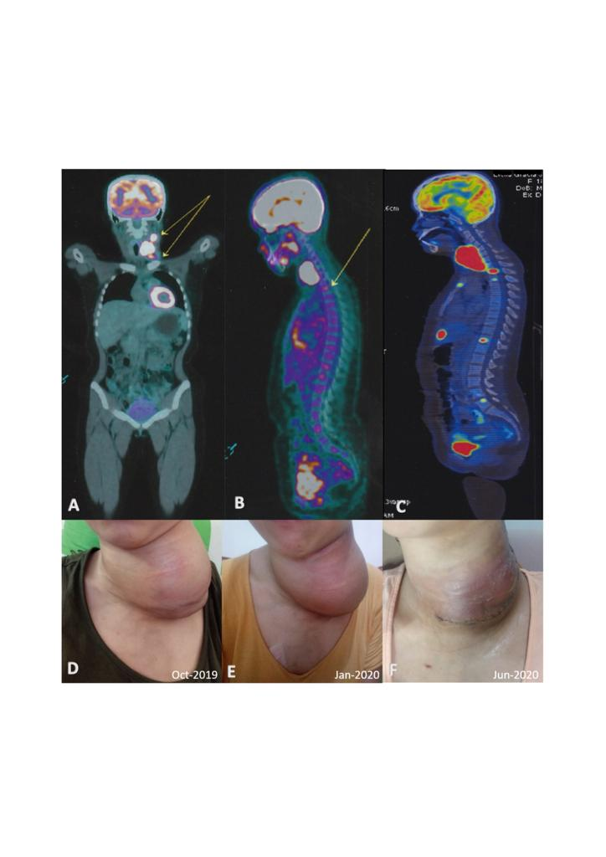

Figure 1. (A-F): Coronal and axial views of patients PET in 2014 (A and B); restaging PET showing progressive disease three years later (C). Clinical views after the first radiotherapy, revealing a left-sided neck mass sized 12 cm x 10 cm x 10 cm (D), after two cycles of temozolomide, sized 10 cm x 8 cm x 8cm (E), and after debulking surgery (F).

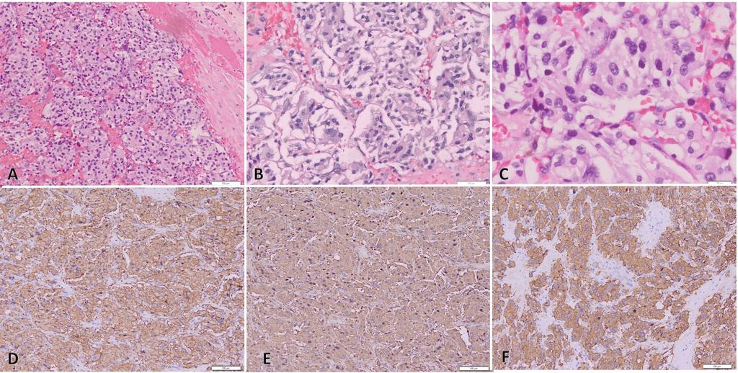

Figure 2 (A-F). Hematoxylin and eosin (H&E) staining from tissue biopsy (A)100x, (B)200x, and (C)400x, showing clusters and packets of small neoplastic cells forming Homer-Wright rosettes, with fairly dispersed chromatin, inconspicuous nucleoli and indistinct cytoplasm. CD56 (D), chromogranin (E), and synaptophysin (F) IHC stains are positive in this tissue.

