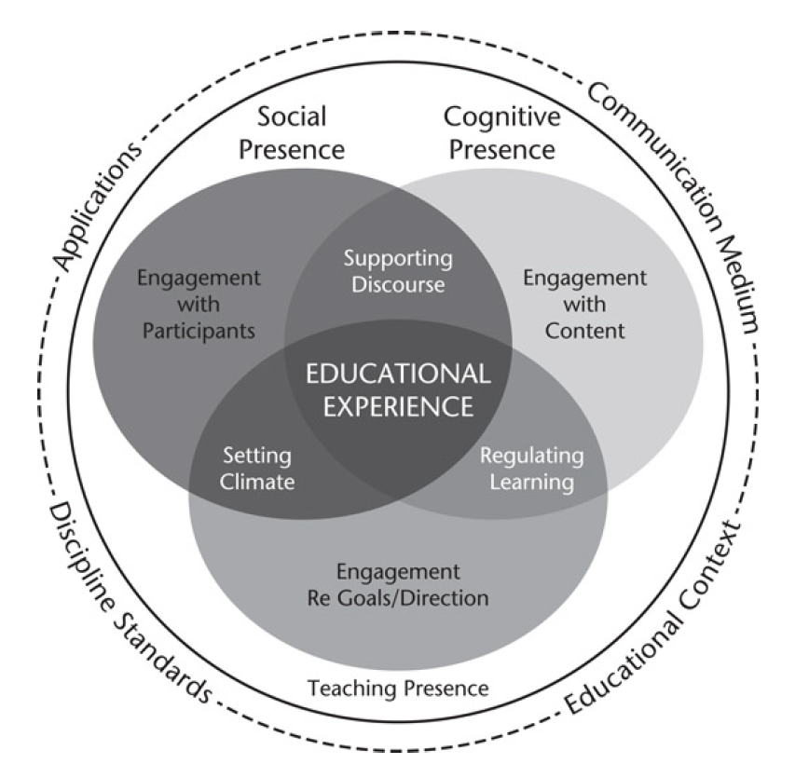

Figure 1:
Community of Inquiry Framework (Source: Garrison 2016; 2017)

Table 1:
The Distinction between Traditional Classroom Learning and E-Learning
 | Traditional Classroom Learning | E-Learning
Advantages | - Immediate feedback  - Being familiar to both instructors and learners  - Motivating students  - Cultivation of a social community | - Learner-centered and self-paced  - Time and location flexibility  - Cost-effective  - Potentially available to global audience  - Unlimited access to knowledge  - Archival capacity for knowledge reuse and sharing
Disadvantages | - Instructor-centered  - Time and location constraints  - More expensive to deliver | - Lack immediate feedback in asynchronous e-learning  - Increased preparation time for the instructor  - Not comfortable for some  - Potentially more frustration, anxiety, and confusion
(Source: Zhang, Zhao, Zhou, & Nunamaker 2004, p.76)

Table 2:
Survey Item Table Specification
Construct | Sub-issue | Survey Item | Note | Cronbach’s Alpha
1 | Engagement in online learning – pre-pandemic | 1-3  (3 items) | No Cronbach’s alpha calculation as it belongs to those yielding nominal or textual data | -
2 | Engagement in online learning – during the pandemic (focus on general IT) | 4-9  (6 items) | Cronbach’s alpha calculation performed to see internal consistency | 0.69
3 | Engagement in Synchronous-asynchronous Writing online course | 10-15  (6 items) | Cronbach’s alpha calculation performed to see internal consistency (excluding one item with yes/no answer) | 0.84
4 | Learning environment prepared for the Writing online course (materials, assignment, assessment etc.) | 16-21  (6 items) | Cronbach’s alpha calculation performed to see internal consistency | 0.68
5 | Learning environment for online vs. face-to face modes | 22-24  (3 items) |  | 0.67
6 | Learning environment focusing on group work | 25-29  (5 items) |  | 0.79
Average Cronbach’s Alpha Value |  |  |  | 0.73

Table 3:
Online Learning Glitches (IT and non-IT Oriented)
Statements | Negative Perception |  | Positive Perception |  | Mean*
 | SD | D | A | SA
C2.1 Not having a good internet connection is my problem in joining Writing-A online course. | 7 | 14 | 18 | 4 | 2.44
 | 16.28%% | 32.56% | 41.86% | 9.30%
C2.2 Not having enough internet quota is my problem in joining Writing-A online course. | 11 | 11 | 13 | 8 | 2.42
 | 25.58% | 25.58% | 30.23% | 18.60%
C2.3 Not having a computer / laptop is my problem in joining Writing-A online course. | 14 | 15 | 9 | 5 | 2.12
 | 32.56% | 34.88% | 20.93% | 11.63%
C2.4 The specification of my computer / laptop cannot support the online learning properly. | 9 | 18 | 10 | 6 | 2.30
 | 20.93% | 41.86% | 23.26% | 13.95%
C2.5 Managing time is my problem in joining Writing-A online course. | 9 | 15 | 16 | 3 | 2.30
 | 20.93% | 34.88% | 37.21% | 6.98%
C2.6 Not having a conducive learning environment at home or my boarding house is my problem in joining Writing-A online course. | 10 | 13 | 15 | 5 | 2.35
 | 23.26% | 30.23% | 34.88% | 11.63%
Note: SD: Strongly Disagree; D: Disagree; A: Agree; SA: Strongly Agree
* A 4-point Likert scale

Table 4:
Synchronous-Asynchronous Perception
Statements | Negative Perception |  | Positive Perception |  | Mean*
 | SD | D | A | SA
C3.1 I joined the scheduled synchronous sessions actively. | 0 | 4 | 25 | 14 | 3.23
 | 0% | 9.30% | 58.14% | 32.56%
C3.2 Apart from the synchronous session, I also did asynchronous session to see any new announcement. | 0 | 3 | 26 | 14 | 3.26
 | 0% | 6.98% | 60.47% | 32.56%
C3.3 Apart from the synchronous session, I also did asynchronous session to see/read the posted materials. | 0 | 4 | 26 | 13 | 3.21
 | 0% | 9.30% | 60.47% | 30.23%
C3.4 Apart from the synchronous session, I also did asynchronous session to review what has been discussed during synchronous session by looking back at the forum or chat facilities. | 2 | 4 | 26 | 11 | 3.07
 | 4.65% | 9.30% | 60.47% | 25.58%
C3.5 Apart from the synchronous session, I also had a small discussion with classmates. | 0 | 3 | 21 | 19 | 3.37
 | 0% | 6.98% | 48.84% | 44.19%
Note: SD: Strongly Disagree; D: Disagree; A: Agree; SA: Strongly Agree
* A 4-point Likert scale

Table 5:
Writing-A Online Course Learning Environment
Statements | Negative Perception |  | Positive Perception |  | Mean*
 | SD | D | A | SA
C4.1 The assignments given helped me understand the writing materials better. | 0 | 1 | 20 | 22 | 3.49
 | 0% | 2.23% | 48.51% | 51.16%
C4.2 The feedback I received from my teacher helped me improve my writing. | 0 | 1 | 16 | 26 | 3.58
 | 0% | 2.33% | 37.21% | 60.46%
C4.3 Writing reflective journals helped me improve my writing | 0 | 2 | 16 | 25 | 3.53
 | 0% | 4.65% | 37.21% | 58.14%
C4.4 I got enough materials to learn Writing-A from my teacher. | 0 | 2 | 21 | 20 | 3.42
 | 0% | 4.65% | 48.84% | 46.51%
C4.5 Apart from materials I got from my teacher, I also tried to get additional online resources to learn the materials on my own. | 3 | 3 | 26 | 11 | 3.05
 | 6.98% | 6.98% | 60.47% | 25.58%
C4.6 I was encouraged to reflect on my learning. | 0 | 3 | 26 | 14 | 3.26
 | 0% | 6.98% | 60.47% | 32.56%
Note: SD: Strongly Disagree; D: Disagree; A: Agree; SA: Strongly Agree
* A 4-point Likert scale

Table 6:
Learning Environment (Online vs. Face-to face Modes)
Statements | Negative Perception |  | Positive Perception |  | Mean*
 | SD | D | A | SA
C5.1. Compared to during pandemic, I mastered the materials more when joining face-to-face classroom instruction. | 2 | 5 | 22 | 14 | 3.12
 | 4.65% | 11.63% | 51.16% | 32.56%
C5.2. Compared to during pandemic, I communicated with my friends and teacher better when joining face-to-face classroom instruction. | 1 | 4 | 23 | 15 | 3.21
 | 2.33% | 9.30% | 53.49% | 34.88%
C5.3. Compared to during pandemic, I got to know my friends more when joining face-to-face classroom instruction. | 1 | 4 | 19 | 19 | 3.31
 | 2.33% | 9.30% | 44.19% | 44.19%
Note: SD: Strongly Disagree; D: Disagree; A: Agree; SA: Strongly Agree
* A 4-point Likert scale

Table 7:
Learning Environment (Small Group Oriented)
Statements | Negative Perception |  | Positive Perception |  | Mean*
 | SD | D | A | SA
C6.1 I had my own small group to discuss the assignments. | 3 | 5 | 21 | 14 | 3.07
 | 6.98% | 11.63% | 48.84% | 32.56%
C6.2 During the small group discussion, I got assisted by my classmates. | 2 | 7 | 23 | 11 | 3
 | 4.65% | 16.28% | 53.49% | 25.58%
C6.3 During the small group discussion, I assisted my classmates. | 1 | 10 | 20 | 12 | 3
 | 2.33% | 23.26% | 46.51% | 27.91%
C6.4 Joining Writing-A online course improved my life skills. | 1 | 3 | 21 | 18 | 3.3
 | 2.33% | 6.98% | 48.84% | 41.86%
Note: SD: Strongly Disagree; D: Disagree; A: Agree; SA: Strongly Agree
* A 4-point Likert scale

