Pre-service high-school computer teachers: A study of relationships between complex variables

Dussadee Terdbaramee, Surachai Suksakulchai, and Elizabeth Murphy

The role of the specialized high-school computer teacher is challenged by both students’ and non-computer teachers’ growing expertise in computers and technology in general. It is also challenged by a need to keep pace with a field that is constantly changing. Yet, few studies have investigated the complex variables that may affect computer teachers’ computer-related performance. This study investigated the relationships between multiple variables including demographics (gender, computer experience, etc.), global self-worth, computer self-concept, computer attitude and achievement. Data collection relied on a survey of 400 pre-service, high-school computer teachers. Implications point to the potential value of opportunities in computer-teacher education for teachers to reflect on personal characteristics such as attitude, self-concept and the effects that may influence their behaviour and experiences as computer teachers.

Keywords: Computer teacher education, Computer self-concept, computer attitude, global self-worth, secondary school

Introduction

At the intersection of education and technology, the teacher has traditionally served in the role of gatekeeper. He or she has been responsible for instructing students on how to use the computer and other digital devices. However, given the present prevalence of technology, the ubiquity of computers and the accessibility of devices, it has become more difficult to discern the role of the teacher at this intersection. This difficulty is perhaps most evident for the computer teacher, sometimes referred to in Australia as secondary IT (information technology) teacher or teacher of senior secondary IT or, simply, information technology educators (Lyons, 2007; Zagami, 2015). These are teachers responsible for helping students learn to use software and operate particular digital devices. These individuals are not, however, simply technicians rather they require “a solid background of pedagogy and knowledge of the learners” (Yadav, Gretter, Hambrusch, & Sands, 2016, p. 4).

Unlike, for example, the mathematics’ or science teacher who can typically assume a degree of expertise compared to students, the computer teacher may be teaching students with as much or more expertise in this subject area. This situation may have been less true in the last century when computers and networked devices were less prevalent. Today, however, particularly given widespread access to smartphones and mobile devices, reports from both developed and developing countries show high use of networked devices. In 2016-2017, Australian students aged 15 to 17 years were the highest proportion of users of networked devices (98%) compared with the older age group (65 years and over) (Australian Bureau of Statistics, 2018). In 2017, in Thailand where this study was conducted, those aged 15 to 24 years were the highest proportion (89.8 %) of Internet users (National Statistics Office Thailand, 2017, p. 2). A European Commission study in 2016 showed that 96% of individuals aged 16-24 years were regular Internet users (Eurostat Statistics Explained, 2017). In the USA, in 2000, 70% of young adults (18 -29 years) used the Internet, and this percentage has grown steadily to 96% in 2015 (Perrin, 2015).

Genrich, Toleman, and Roberts (2014) surveyed Queensland students’ “perceptions affecting their decision to study information technology in later years of high school and at university.” Their results revealed that only 39% agreed that “their IT teachers in middle school were experts in their field,” only 45% “felt that their teachers were able to explain IT concepts well,” and only “43% felt that their teachers made learning IT interesting.” The authors concluded that “there is scope for considerable improvement by many of the teachers.” Computer teachers are also increasingly challenged professionally by their colleagues’ growing integration and expertise with technology. The International Computer and Information Literacy Study (ICLIST) found that national percentages for the weekly use of computers was at 90 % in Australia (Fraillon, Ainley, Schulz, Friedman, & Gebhardt, 2014) and that “the majority of [Australian] teachers use computers for instructional purposes on a regular basis” (Drossel, Eickelmann & Gerick, 2017). At an international level, as noted by a 2013 study, 60% of high-school teachers use computers at a minimum, once per week (Fraillon et al., 2014). While not all countries may evidence the same high levels of integration, what is noteworthy in this context is that the role of the previously specialized computer teacher is overshadowed by non-computer teachers’ growing integration of and expertise in computers.

It is not surprising that computer teachers face various challenges in their profession. Deryakulu and Olkun’s (2007) study of Turkish computer teachers identified problems such as role conflict, lack of appreciation and positive feedback from colleagues as well as the “rapidly changing nature of content knowledge in computer education” (p. 134). The computer teachers in their study identified a lack of support, feedback and respect for their expertise leading to their feeling “more sensitive or intolerant of the employment of out-of-field persons as computer teachers at public schools” (p. 135). A further problem was the need to update their knowledge continually. Similarly, Lian (2017) noted the challenges for computer teachers in terms of the need to improve their knowledge about and skills with new media. Song (2014) found regarding vocational high school computer teachers that their knowledge was not keeping pace with developments in the field.

Variables that affect computer teachers’ performance

The challenges facing high-school computer teachers make evident the need to gain insights into the complex variables that can interact to affect computer teachers in their profession. Not surprisingly, researchers have shown considerable interest in predictors of teachers’ ICT integration although this interest has tended to focus on teachers in general and not on computer teachers in particular. Areas that have been investigated include computer attitude and computer self-concept as well as demographic factors such as gender and computer experience. Previous studies (e.g., Sang, Valcke, Braak, & Tondeur, 2010) have identified that “attitudes toward computer use in education seem to be the strongest predictor of prospective computer use” (p. 7). Computer attitudes are influenced by different variables such as perceived usefulness (Teo, Lee, & Chai, 2008), computer confidence (Rovai & Childress, 2002), training (Tsitouridou & Vryzas, 2003), gender (Sadik, 2006), knowledge about computers (Yuen & Ma, 2001), computer anxiety (Teo, 2008) and computer experience (Kumar & Kumar, 2003; Potosky & Bobko, 2001). In most cases, many of these variables interact with one another to impact attitudes towards computers. Teachers’ attitudes towards computers have been shown by various studies to be a critical factor that affects technology use and integration in teaching and learning (Teo, 2008, p. 414). Fear, ignorance and anxiety are attitudes that can interfere with the adoption of information and communication technologies (ICTs) in teaching and learning (Larbi-Apau & Moseley, 2012). In general, attitudes affect performance and the overall efficiency of computer and technology use (Christoph, Goldhammer, Zylka, & Hartig, 2015). “Gaining an appreciation of the teachers’ attitudes towards computer use may provide useful insights into technology integration and acceptance and usage of technology in teaching and learning” (Teo, 2008, p. 415).

Computer self-concept is another variable that may affect computer teachers’ teaching. Computer self-concept affects a person’s computer-related performance and is affected by a person’s actions as well as experiences with computers and a person’s individual environment (Langheinrich, Schonfelder, & Bogner, 2016). Computer self-concept includes a mix of computer-related skills, interest, experiences, attitudes and beliefs (Janneck, Vincent-Höper, & Ehrhardt, 2013). Langheinrich et al. (2016) pointed out that while self-concept has received attention from researchers for “decades” computer self-concept is a new construct. Researchers have also recognised that different individual environments contribute to different self-concepts i.e., self-concept (SC) is context dependent (Bracken, 1992). Bracken and Howell (1991) conceptualized self-concept as Multidimensional Self-Concept (MSC) which includes six contextual domains of social SC, competence (ability) SC, affective SC, academic SC, family SC and physical SC. More recently, Neeman and Harter (2012) focused on a broader perspective on SC which they referred to as global self-worth (GSW). Neeman and Harter’s GSW scale includes “Twelve domains, besides self-worth” in recognition that college students are still “integrated into the school setting” therefore, items such as “scholastic and athletic competence and social acceptance” are included. However, because students are also adults, the authors included elements such as “morality, intelligence, appearance, and sense of humor.” Finally, the authors included elements such as “close friendships, romantic relationships, and job competence” in addition to “creativity and the self in relation to parents” (p. 6).

Another dimension that has been investigated in relation to computer use is that of demographic factors. Gender is a factor that has been explored widely. Kadijevich (2000) found that males were more likely than females to show positive attitudes toward computers “even when computer experience was controlled” (p. 145). Schumacher and Morahan-Martin (2001) found regarding in-coming students that males had more computer experience and higher skill levels. Another demographic factor that has been investigated is that of computer experience. For example, Yildirim’s (2000) study of teachers associated frequency of computer use with more positive attitudes that encouraged subsequent computer use. Cocorada’s (2015) review of studies of computer use and experience referred to “divergent” and “contradictory” results (p. 22) regarding years of computer experience and computer attitude. Regarding age and computer use, Yan and Fischer (2004) argued that there is a lack of research regarding developmental differences in computer use and that it was a “myth” that children learn to use computers more easily than adults.

Schumacher and Morahan-Martin (2001) found a positive relationship between computer experiences, skills and attitudes. The authors also found that males were more experienced and had “higher skill levels with the Internet than females” (p. 95). Kubiatko and Haláková (2009) found that “younger students had more positive ICT attitudes than their older counterparts.”

In spite of these various studies on demographic factors, computer attitude and self-concept etc., as Tondeur, Aesaert, Prestridge, and Consuegr (2018) observed, what is needed in the research is a more “holistic approach” that considers “many influencing characteristics in conjunction with each other” (p. 12). Tondeur et al. (2018) explained that the focus needs to consider an “integral, multidimensional relationship between individual ICT competencies and a set of personal and institutional characteristics” (p. 12). The review of the literature conducted for this study did not uncover any studies that took a holistic approach that combine computer attitude, computer self-concept, global self-worth and demographic factors such as gender that may help understand pre-service computer teachers’ computer-related performance.

Purpose and research questions

The purpose of this study was to take a holistic approach to the investigation of the variables that may influence pre-service high-school computer teachers’ computer-related performance and to understand the relationship between these variables. Research questions were as follows:

- Do pre-service computer teachers’ demographics (gender, year of study, computer experience and daily computer use) or global self-worth predict their computer self-concept (CSC), computer attitude (CA) or achievement as measured by Grade Point Average (GPA)?

- What is the relationship between pre-service computer teachers’ (CA), (GSW), (CSC), GSW and GPA?
a) Overall using regression analysis?
b) Does CA influence GPA?
c) Does CSC influence GPA?
d) Does CA influence CSC?
e) Does GSW influence CA?
f) Does GSW influence CSC?

Literature review

The literature review focused on studies closest to the present study, i.e., on CSC, CA, demographics, GPA and GSW in relation to pre-service, prospective, student teachers only. In that regard, the review excluded studies that focused on in-service teachers. The review is limited to the period 2008-2018 based on the assumption that studies prior to this decade would have less relevance to this context. The search for studies included not only computers but ICTs and the Internet and networked-based computer technologies.

The review uncovered primarily studies conducted with teachers in other subject areas besides computer studies. For example, Teo (2010) focused on CA, demographics, technological complexity and subjective norms with pre-service teachers of Art. In relation to GSW, the review did not identify any studies of pre-service computer teachers. The review identified one study with in-service teachers. Agbatogun (2010) conducted a study of 454 Nigerian secondary-school teachers. The study relied on surveys of their Multi-dimensional self-concept (MSC), computer anxiety, gender and attitude towards interactive computer technologies. Agbatogun (2010) found that “MSC, computer anxiety can predict teachers’ attitudes towards computer technologies” (p. 55).

In relation to CA, there have been many studies of pre-service teachers conducted in various countries such as Spain (e.g., Lambert, Gong & Cuper, 2008), Singapore (e.g., Teo, 2010), China (e.g., Sang, Valcke, Braak, and Tondeur, 2010) and Malaysia (e.g., Teo et al., 2008). The variables that have been investigated include perceived computer ability (Lambert et al., 2008), technology acceptance (Teo et al., 2008), computer experience (Teo, 2008), computer self-efficacy (Pamuk & Peker, 2009; Sang et al., 2010), gender (Pamuk et al., 2009; Sang et al., 2010), self-perception of computing skills (Külekçı, 2009), ICT-related characteristics, intensity of ICT use at home, intensity of ICT use for educational purposes (Tondeur et al., 2018) and ICT competence (Yusuf & Balogun,2011). Studies have also been conducted regarding CA and in-service teachers. For example, Rana (2016) focused on CA with in-service teacher educators. Rana found that there were “no gender differences” with regards to ICT attitudes (p. 190).

Table 1 presents a summary of studies that focus on pre-service teachers and variables that influence or predict their computer use and ICT integration. All of the studies relied on surveys to collect data. The summary makes evident the lack of attention focused specifically on pre-service computer teachers (as opposed to subject-area teachers integrating ICTs.) The summary also makes evident the lack of a combined holistic focus on CSC, CA, GSW, GPA and demographics.

Table 1

Summary of studies (2008-2018) focused on pre-service teachers

Study | Location | N | Subject | Sites | Investigated factors
Lambert et al. (2008) | Spain | 62 | *NS | 1 | CA  Perceived computer  ability
Teo et al.  (2008) | Singapore &  Malaysia | 495 | *NS | 2 | CA  Technology acceptance
Teo  (2008) | Singapore | 139 | General | 1 | CA  Computer experience
Pamuk et al.  (2009) | Turkey | 605 | Science & mathematics | *NS | CA  Computer  self-efficacies  Gender  Year in program  Computer ownership
Külekçı (2009) | Turkey | 195 | English | 1 | CA  Self-perception of  computing skills
Sang et al.  (2010) | China | 727 | Mathematics  English  Science  Educational technology & Art | 4 | CA  Gender  Constructivist teaching  beliefs  Teaching  self-efficacy  Computer self-efficacy
Teo  (2010) | Singapore | 239 | Art | 1 | CA  Demographics  Technological  complexity  Subjective norm
Yusuf et al.  (2011) | Nigeria | 382 | Secondary school subjects | 1 | CA  ICT competency
Tondeur et al. (2018) | Flanders Belgium & Netherlands | 931 | Primary-school teachers | 20 | Demography  ICT-related  characteristics  (e.g., attitudes and ease  of use)  Intensity of ICT use  at home  Intensity of ICT use  for educational purposes
*NS = Not specified

The present study differs from those listed in this summary in that it is specifically focused on pre-service computer teachers and not, for example, teachers of art or other subjects. The present study also takes a holistic investigation of five different variables that and relate to each other including, CA, CSC, GSW, demographics and GPA. Results of this study will be relevant in particular for pre-service teacher-education programs as well as in-service teacher professional development in terms of furthering understanding about complex variables that may influence computer teachers’ computer-related performance.

Methodology

Participants

Participants (N=400) were selected from three sites: one large university in Bangkok, Thailand (17,481 students) and from two smaller universities (>9, 000 students) in Northern Thailand. All participating students were enrolled in a pre-service teacher program specializing in high-school computer education. Their teacher-education program lasts for five years. Students must complete general courses such as those in curriculum and instruction and evaluation and assessment etc. They must select an area of specialization such as mathematics education, science education or, in this case, computer education. In their specialized area, they must complete a total of 44 courses. Examples of some of the 26 courses in the computer-education program include programming, database management, computer network and data communication, computer architecture and operating system, graphic design, methodology in teaching computers and projects for computer education. Table 2 summarizes participants’ demographics.

Table 2

Demographics of participants (N=400)

 | N | %
Gender
Male | 212 | 53
Female | 188 | 47
Year of study
1 | 38 | 10
2 | 153 | 38
3 | 109 | 27
4 | 100 | 25
Computer experience
>4 years | 242 | 60
3-4 years | 93 | 23
1-2 years | 50 | 13
<1 year | 15 | 4
Daily computer use
1-2 hours | 95 | 24
3-4 hours | 127 | 32
5-6 hours | 85 | 21
>6 hours | 93 | 23

Instrument

The items for the survey (see tables 3, 4, 5) were adapted from existing surveys. The GSW items were adapted from Neeman and Harter (2012). Neeman and Harter’s scale was designed for post-secondary students and therefore matches well with the group in this study. It includes 13 domains. Our survey relied on a three-point Likert scale with Agree, Not sure and Disagree. We selected a three-point scale to ensure that respondents “clearly express, either a positive or negative feeling about the issue under consideration” (Petty & Cacioppo, 2018, p. 11). Table 3 summarizes the GSW survey items.

Table 3

Global self-worth measurement scale, sample items and Cronbach’s alpha values

Measurement | Sample items | N  of items | α
Job competence | I feel I am very good at my job. | 4 | .894
Scholastic competence | I have trouble figuring out assignments. | 4 | .793
Social acceptance | I am not satisfied with my social skills. | 4 | .787
Appearance | I am happy with the way I look. | 4 | .808
Parent relationships | I like the way I act when I am around family members. | 4 | .813
Close friendship | I find it hard to make new friends. | 4 | .801
Intellectual ability | I do very well at my studies. | 4 | .779
Morality | I usually do what is morally right. | 4 | .792
Romantic relationship | I find it hard to establish romantic relationships. | 4 | .778
Humour | I don’t mind being kidded by my friends. | 4 | .795
Creativity | I worry that I am not as creative or inventive as other people. | 4 | .779
Athletic competence | I don’t feel that I am very athletic. | 4 | .798
Global self-worth | I usually like myself as a person. | 6 | .805
*α = Cronbach’s alpha

The CA survey was adapted from Teo (2008). Teo (2008) used an instrument by Selwyn (1997) to measure pre-service teachers’ attitudes towards computer use called the Computer Attitude Scale (CAS). The instrument included 21 items focused on four components of computer attitudes. The first component, ‘Affect’, is composed of six items and measures feelings towards computers. ‘Perceived Usefulness’ is composed of five items that measure the individual’s beliefs about the usefulness of computers in their job. ‘Perceived Control’ is composed of six items that measure the perceived comfort level or difficulty of using computers. The fourth component, ‘Behavioral Intention,’ is composed of four items that measure behavioural intentions and actions with respect to computers. The Likert scale had five items ranging from strongly disagree to strongly agree.

Table 4

CA measurement scale, sample items and Cronbach’s alpha

Measurement | Sample items | N  of items | α
Affect | If I use a computer, I fear doing something wrong. | 6 | .704
 | I don't feel apprehensive about using a computer.
Perceived usefulness | Computers help me improve my work. | 6 | .744
 | Computers can allow me to do more interesting and imaginative work
Perceived control | When I use a computer, I need help from a computer expert. | 5 | .752
 | I do not need someone to tell me the best way to use a computer.
Behavioural intention to use the computer | I don’t like to work or use computer in my job. | 4 | .719
 | I only use computers at school when I am told to.
*α = Cronbach’s alpha

The CSC measures were designed by Langheinrich et al. (2016) who explain their measures as follows:
The conative component refers to experiences during life (e.g., concrete actions or behaviours), the motivational component includes all emotions and attitudes toward computers like, for example, computer anxiety or individual motives for using computers, and, at least, the cognitive component which involves self-perceived computer competencies, self-efficacy and individual strategies for handling computers as well as computer-related attribution processes. (p. 355)

Table 5

CSC measurement scale, sample items and Cronbach’s alpha

Measurement | Sample items | N  of items | α
External
Conative | How much computer experience do you have? | 2 | .759
 | For how many hours do you use a computer each day?
Motivational | How often do you use the computer for surfing the Internet? | 6 | .733
 | How often do you use the computer for programming?
Cognitive | How do you assess your abilities in the handling of computers in general? | 6 | .733
How do you assess your abilities in
programming correcting faults/ understanding error messages/ technical defaults?
Internal | It’s very important for me to work with computers. | 11 | .733
 | I really enjoy gaming or working with a computer.
*α = Cronbach’s alpha

Procedures

Survey items were translated into the Thai language, and students completed the survey in Thai. Results and survey items were translated into English for this paper. Students completed the survey after class. They were informed that their participation was voluntary and that results would be aggregated and presented anonymously. The principal investigator administered the survey, and the instructor was not present. The survey required approximately 20 minutes to complete.

Data analysis

Data analysis involved calculation of correlation coefficients between GSW, CA and CSC. Calculation of correlation coefficients is a technique used to identify relationships between multiple variables. The analysis also relied on stepwise multiple regression. According to Halinski and Feldt (1970), multiple regression “enables the researcher to obtain a reduced set of variables from a larger set of predictors, eliminating unnecessary predictors, simplifying data and enhancing predictive accuracy” (p. 151).

Results

Research question 1: Do pre-service teachers’ demographics (gender, year of study, computer experience and daily computer use) or global self-worth (GSW) predict their computer self-concept (CSC), computer attitude (CA) or achievement (GPA)?

Predictors of CSC

Experience in computer use significantly predicted CSC tendencies ($β$= 0.489, p= .01). For experience in computer use, there was a 0.489 increase in CSC for each point of extra year of experience in computer use. The R² value was 0.239 meaning that 23.9 % of the variance in CSC can be explained by the model containing only the experience in computer use. This is low so predictions from the regression equation are reliable (F (1,395) = 124.161, p= .000). Table 6 and figure 1 show the results of the predictors of CSC.

Figure 1. Predictors of CSC

Table 6

Multiple regression results for predictors of CSC

Predictor variable | B | Std. Error | β | t | Sig. | R | R Square | Adjusted R Square | Std. Error  of the Estimate
Computer  Experience | .355 | .032 | .489 | 11.143 | .000 | .489 | .239 | .237 | .41057
*p< .05, **p < .01
Predictors of CA

Gender ($β$= -0.128, p= .01) and GSW ($β$= 0.125, p= .01) significantly predicted CA. The binary variable of Gender is coded as 0=female and 1=male. The female computer pre-service teachers had more positive CA than their male computer pre-service teachers. Figure 2 and Table 7 show results of the predictors of CA. The prediction model contained two of the five predictors of CA. The R² value was 0.030 meaning that 3 % of the variance in CA can be explained by the model containing gender and GSW. This is low so predictions from the regression equation are reliable (F (2,394) = 6.16, p< .001).

Figure 2. Predictors of CA

Table 7

Multiple regression results for CA

Predictor variable | B | Std. Error | β | t | Sig. | R | R Square | Adjusted R  Square | Std. Error of the Estimate
Gender | -.142 | .055 | -.128 | -2.580 | .010 | .174 | .030 | .025 | .54739
GSW | .462 | .18 | .125 | 2.520 | .012
*p< .05, **p < .01

Predictors of GPA

Experience in computer use significantly predicted GPA tendencies ($β$= .238, p<.01), as did year of study ($β$= .234, p<.01). For the experience in computer use, there was a 0.238 increase in GPA for each point of extra year of experience in computer use. The prediction model contained two of the five predictors of GPA. The R² value was 0.083 meaning that 8.3 % of the variance in GPA can be explained by experience in computer use and year of study. This value is low meaning that predictions from the regression equation are reliable (F (2,394) = 17.761, p <.001). For each increase in year of study, the GPA increased by 0.234. Table 8 and figure 3 show results of the predictors of GPA.

Figure 3. Predictors of GPA

Table 8

Multiple regression results for GPA

Predictor variable | B | Std. Error | β | t | Sig. | R | R Square | Adjusted R Square | Std. Error of the Estimate
Computer  experience | .374 | .079 | .238 | 4.761 | .000 | .288 | .083 | .078 | .980
Year of study | .245 | .052 | .234 | 4.689 | .000
*p< .05, **p < .01

Research question 2: What is the relationship between CA, GSW, CSC, CA and GPA?

Overall using regression analysis

Pre-service teachers’ perceptions of their CSC (external and internal) were positively correlated with GPA, GSW and CA. There was a low to moderate correlation between the significant variables (from 0.090 to 0.029). Moreover, teachers’ GPAs were positively correlated with CA. Table 9 summarizes the mean, standard deviations, and inter-correlations between the major variables.

Table 9
Mean, standard deviations, and inter-correlations between the major variables (N=400)

 | CSC | GSW | CA | M | SD
GPA | 0.087 | 0.095 | 0.278** | 3.21 | 1.024
CSC |  | 0.090 | 0.029 | 3.23 | 0.470
GSW |  |  | 0.111* | 1.92 | 0.150
CA |  |  |  | 3.60 | 0.555

*p< .05, **p < .01

Does CA influence GPA?

Affect significantly predicted GPA ($β$= .208, p<.01), as did behavioral intention to use the computer ($β$= .123, p=0.23). Participants’ mean GPA increased by 0.208 points for each positive attitude and GPA increased 0.123 for behavioral intention to use the computer. The prediction model contained two of the four predictors of GPA. The R² value was 0.082 so 8.2 % of the variance in GPA can be explained by the variables of affect and behavioral intention to use the computer. This value is quite low meaning that predictions from the regression equation are reliable (F (2,397) =17.714, p<.001). Figure 4 and table 10 show results.
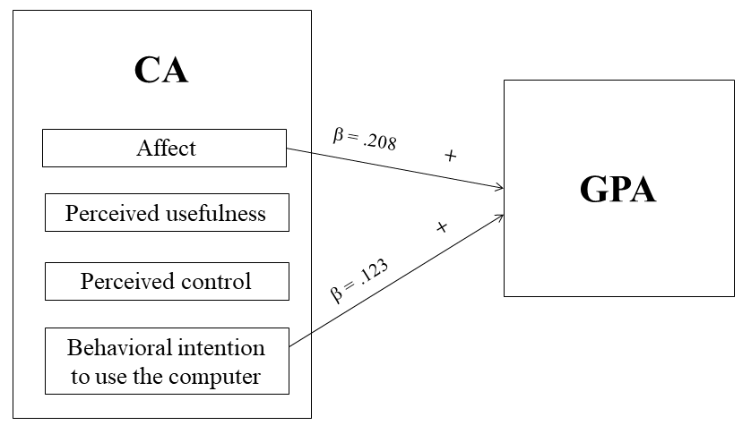
Figure 4. CA’s influence on GPA

Table 10

Standard regression results

Predictor variable | B | Std. Error | β | t | Sig. | R | R Square | Adjusted R  Square | Std. Error of the Estimate
Affect | .214 | .056 | .208 | 3.846 | .000 | .286 | .082 | .077 | .206
Behavioural intention | .121 | .053 | .123 | 2.280 | .023
*p< .05

Does CSC influence GPA?

Conative CSC significantly predicted GPA ($β$= .179, p<.01). Participants’ mean higher computer experience predicted higher GPA by 0.179 points. The prediction model contained one of the four predictors of GPA. The R² value was 0.032 meaning that 3.2 % of the variance in GPA can be explained by the variables of computer experience. This is quite low so predictions from the regression equation are reliable (F (3,396) = 12.541, p<.001). Figure 5 and table 11 show results.
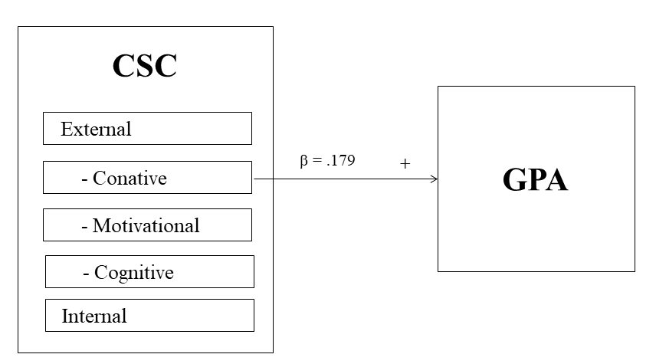
Figure 5. CSC’s influence on GPA

Table 11

Standard regression results

Predictor variable | B | Std. Error | β | t | Sig. | R | R Square | Adjusted R Square | Std. Error of the Estimate
Conative | .282 | .077 | .179 | 3.638 | .000 | .179 | .032 | .030 | 1.009
*p< .05

Does CA influence CSC?

Perceived control significantly predicted CSC tendencies, as did affect. Participants’ mean CSC increased by 0.230 points for each perceived control intention to use the computer. Participants mean CSC increased 0.188 points. The prediction model contained two of the four predictors of CSC. The R² value was 0.070 meaning that 7 % of the variance in CSC can be explained by the variables of perceived control and affect. This value is quite low meaning that predictions from the regression equation are reliable (F (2,397) = 15.030, p<.001). Figure 6 and table 12 show the results.

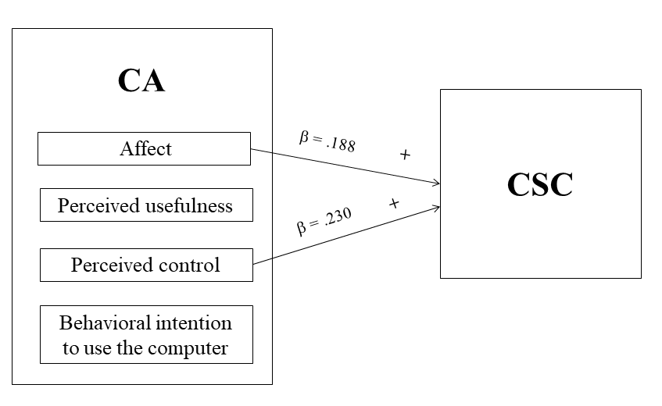

Figure 6. CA’s influence on CSC

Table 12

Standard regression results

Predictor variable | B | Std. Error | β | t | Sig. | R | R Square | Adjusted R Square | Std. Error of the Estimate
Perceived control | .230 | .049 | .230 | 4.652 | .000 | .265 | .070 | .066 | .467
Affect | .091 | .024 | .188 | -3.803 | .000
*p< .05

Does GSW influence CA?

Pre-service teachers’ perceptions of their creativity, global self-worth, scholastic competence and athletic competence significantly predicted CA. Creativity resulted in a 0.174 increase in CA. Global self-worth resulted in a 0.152 increase in CA. Athletic competence resulted in a 0.132 increase in CA. High scholastic competence resulted in a 0.153 increase in CA. The prediction model contained four of the thirteen predictors of CA. The R² value was 0.083 meaning 8.3 % of the variance in CA of computer pre-service teachers can be explained by the variables of creativity; global self-worth; scholastic competence; and athletic competence. This value is low meaning that predictions from the regression equation are reliable (F (4,395) = 8.992, p<.001). Figure 7 and table 13 show the standard regression results.

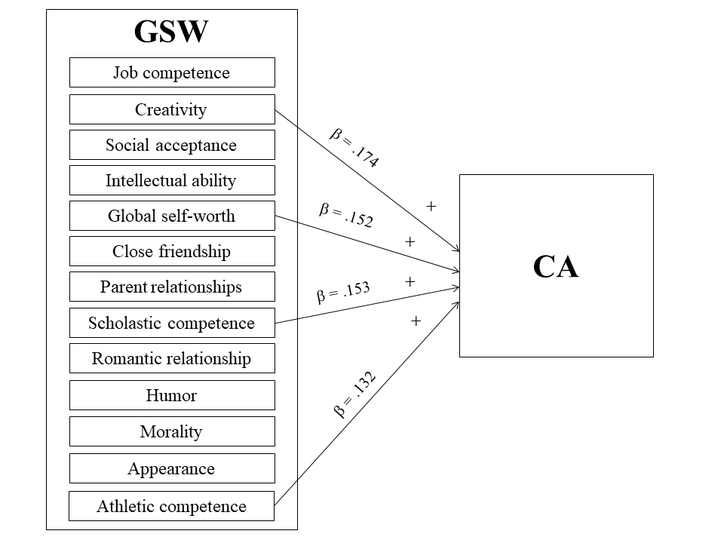
Figure 7. GSW’s influence on CA

Table 13

Standard regression results for GSW and CA

Predictor variable | B | Std. Error | β | t | Sig. | R | R Square | Adjusted R Square | Std. Error of the Estimate
Creativity | .306 | .092 | .174 | 3.344 | .001 | .289 | .083 | 0.074 | .534
Global  self-worth | .304 | .097 | .152 | 3.138 | .002
Scholastic  competence | .310 | .104 | .153 | 2.983 | .003
Athletic  competence | .218 | .084 | .132 | 2.605 | .010
*p< .05

Does GSW influence CSC?

Teachers’ positive perceptions of their physical attractiveness, happiness with their appearance, positive perceptions of their intellectual ability and positive perceptions of their scholastic competence significantly predicted CSC tendencies. Happiness with their appearance was positively related with the CSC. Intellectual ability was also positively related to CSC and scholastic competence was positively related to CSC. The prediction model contained three of the thirteen predictors CSC. The R² value was 0.059 meaning that 5.9 % of the variance in teachers’ CSC can be explained by the predictors of appearance, intellectual ability and scholastic competence. This value is low meaning that predictions from the regression equation are reliable (F (3,396) = 8.349, p<.001). Figure 8 and Table 14 show results.

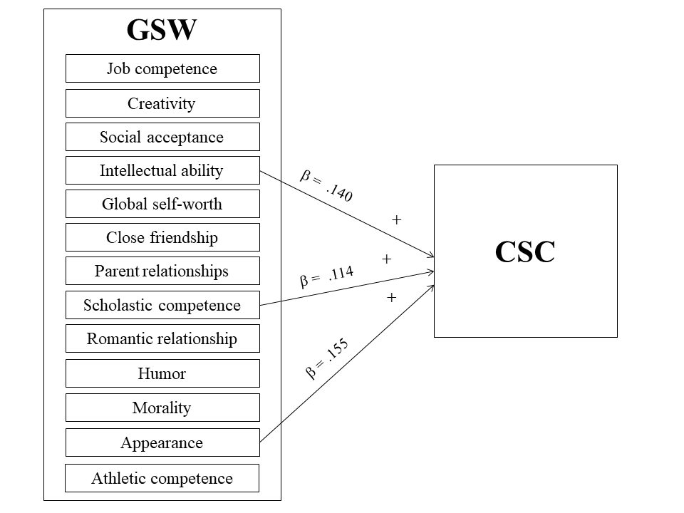
Figure 8. GSW’s influence on CSC

Table 14

Standard regression results for GSW and CSC.

Predictor variable | B | Std. Error | β | t | Sig. | R | R Square | Adjusted R Square | Std. Error of the Estimate
Intellectual  ability | .187 | .068 | .140 | 2.740 | .006 | .244 | .059 | 0.052 | .471
Scholastic  competence | .202 | .088 | .114 | 2.288 | .023
Appearance | .218 | .070 | .155 | 3.114 | .002
*p< .05

Discussion

This study was conducted to understand the relationship between pre-service high-school computer teachers’ demographics, global self-worth (GSW), computer self-concept (CSC), computer attitude (CA) and achievement (GPA). Demographics included gender, year of study, computer experience and daily computer use. GSW refers to elements such as relationships, friendships, humour (see figure 8). In addition, we investigated the relationship between their CA, GSW, CSC and their GPA in their computer education courses. In summary, results revealed that computer experience predicted CSC, being female and GSW predicted CA, year of study and computer experience predicted GPA. Affect as a variable related to CA (e.g., I don't feel apprehensive about using a computer) and behavioural intention to use the computer (e.g., I only use computers at university when I am told to) predicted GPA.

Affect as part of CA (e.g., If I use a computer, I fear doing something wrong) and perceived control (e.g., When I use a computer, I need help from a computer expert) predicted CSC.
CSC predicted GPA. The variable of creativity as part of GSW (e.g., I worry that I am not as creative or inventive as other people) and overall GSW (e.g., I usually like myself as a person), scholastic competence (e.g., I have trouble figuring out assignments), and athletic competence predicted CA. Intellectual ability as a variable of GSW (e.g., I do very well at my studies), scholastic competence (e.g., I rarely have trouble with my homework assignments) and appearance (e.g., I am happy with the way I look) predicted CSC.

In relation to gender, in this study, females, as opposed to males, were more likely to have a positive computer attitude. This result contradicts the finding of previous studies that did not identify gender differences for computer attitude (e.g., Shapka & Ferrari, 2003; Yuen & Ma, 2002). It also contradicts findings of studies that associated higher self-efficacy and lower anxiety with male college students in relation to Internet use (e.g., Sun, 2008). Durndell and Haag’s (2002) study of university students also reported more positive attitudes regarding Internet use than did females. Similarly, Sadik (2006) found that males “had more positive attitudes towards computers than did females.” Yet, results did not reveal any significant relationships for gender and computer self-concept or gender and GPA in their computer education. This finding is unlike that of Sáinz and Eccles (2011) who concluded that for males, computer self-concept increased over time whereas it decreased over time for females (p. 10). Also, Janneck et al. (2013) reported that “men have a significantly more positive computer-related self-concept than women” (p. 1).

In this study, having a better computer attitude improved achievement and higher GPA is also reflected in the positive computer self-concept. Teachers’ year of study did not significantly predict their CSC or their CA. However, their year of study did predict their GPA. Results showed that the higher the teachers’ computer experience, the higher their CSC. There were no significant relationships between computer experience and CA. Almeida, Jameson, Riesen, and McDonnell (2016) had similar results in their study of pre-service special education teachers. Almeida et al. (2016) interpreted the correlation between GPA and self-efficacy as a reciprocal relationship whereby:

Students with a higher GPA are more willing and motivated to use a variety of resources and, thus, engage with technology more, or that this motivation and willingness to engage with technology… translates to better use of resources and a higher GPA. (p. 16)

Conclusion

The results confirm the arguments of Chong, Low and Goh (2011) regarding the preparation of pre-service teachers and the need to consider their beliefs, behaviour and personal identity and “emerging professional identity.” They also confirm Teng’s (2017) conclusions regarding “the emotionality of learning to teach” and the need to ‘navigate’ the “conflicting emotions in the process of becoming a teacher” (p. 131). They confirm Drossel, Eickelmann and Gerick’s (2016) argument that research on ICT integration needs to “rely on teachers’ individual perceptions” and that attitudes, perceived ICT self-efficacy, “conviction and confidence” have a significant impact on their ICT integration.

Results of this study point to the potential value in pre-service computer-teacher education of attention to non-technological, personal traits that may ultimately influence computer teachers’ computer-related performance. It was beyond the scope of this study to investigate if or to what degree the predictors translate into or affect actual classroom behaviours. The study was limited to self-report measures which may not be a true measure. However, the results suggest a need in computer-education programs to go beyond an emphasis on pedagogical content knowledge (PCK) (Shulman, 1987) and even beyond Technological Pedagogical Content Knowledge (TPCK) (Koehler, Mishra & Yahya, 2007). Going beyond PCK and TPCK would involve a more holistic emphasis in computer teachers’ education on the very personal attributes that combine in hidden and complex ways to influence teachers’ relationship with technology and with their role as technology and computer teachers. These results suggest that effective computer-teacher education requires what Mueller and Wood (2012) refer to as “sensitivity to individual and contextual variables” (p. 1) in a context of evolving technology where, in spite of continuous learning, teachers end up being “perpetual novices” (Mueller, Wood, and Willoughby, 2008).

In terms of implications for practice and policy, pre-service computer teachers may benefit from opportunities that invite them to reflect on the personal characteristics such as attitude, self-concept and affect that may potentially influence their computer-related performance. Such opportunities might include engagement in “meta-conceptual awareness” whereby they have scaffolded opportunities to reflect on their competence and develop sensitivity to the specific contextual professional demands (Krauskopf, Foulger, & Williams, 2018). Dedicated courses or seminars might help them articulate underlying emotions or affective issues that arise from the challenges of being a specialized computer teacher. In an era where increasingly non-computer-teaching colleagues, as well as students, may possess high levels of technological knowledge, those challenges may be worthy of more in-depth attention. In terms of implications for research, it was beyond the scope of this study to understand the ‘why’ behind teachers’ self-reports. For example, why and how would perceptions related to appearance or athleticism affect or predict computer attitude? These are questions that may be explored in future research.

References
Agbatogun, A. (2010). Self-concept, computer anxiety, gender and attitude towards
interactive computer technologies: A predictive study among Nigerian teachers.
International Journal of Education and Development using Information and Communication Technology, 6(2), 55-68.

Almeida, M., Jameson, M., Riesen, T., & McDonnell, J. (2016). Urban and rural preservice
special education teachers' computer use and perceptions of self-efficacy. Rural Special Education Quarterly, 35(3), 12-19. doi:10.1177/875687051603500303

Australian Bureau of Statistics. (2018). Household use of information technology Australia,
2016-17. Retrieved from http://www.abs.gov.au/ausstats/abs@.nsf/mf/8146.0

Bracken, B. (1992). Examiner’s manual for the Multidimensional self-esteem scale. Austin,
TX: Pro-Ed.

Bracken, B., & Howell, K. (1991). Multidimensional self concept validation: A three-
instrument investigation. Journal of Psychoeducational Assessment, 9(4), 319-328. doi:10.1177/073428299100900403

Chong, S., Low, E., & Goh, K. (2011). Emerging professional teacher identity of pre-
service teachers. Australian Journal of Teacher Education, 36(8), 50-64.

Christoph, G., Goldhammer, F., Zylka, J., & Hartig, J. (2015). Adolescents' computer
performance: The role of self-concept and motivational aspects. Computers & Education, 81, 1-12. doi:10.1016/j.compedu.2014.09.004

Cocorada, E. (2015). The internet attitude with socio-humanities high-school and university
students. Romanian Journal of Experimental Applied Psychology, 6(1).

Deryakulu, D., & Olkun, S. (2007). Analysis of computer teachers' online discussion forum
messages about their occupational problems. Journal of Educational Technology & Society, 10(4).

Drossel, K., Eickelmann, B., & Gerick, J. (2017). Predictors of teachers’ use of ICT in
school–the relevance of school characteristics, teachers’ attitudes and teacher
collaboration. Education and Information Technologies, 22(2), 551-573.
doi:10.1007/s10639-016-9476-y

Durndell, A., & Haag, Z. (2002). Computer self efficacy, computer anxiety, attitudes towards
the Internet and reported experience with the Internet, by gender, in an East European sample. Computers in Human Behavior, 18(5), 521-535. doi:10.1016/S0747-5632(02)00006-7

Eurostat Statistics Explained. (2017). Internet access and use statistics, households and
individuals 2016. Retrieved from http://ec.europa.eu/eurostat/statistics-
explained/index.php/Archive:Internet_access_and_use_statistics_-
_households_and_individuals_-_2016_edition#Internet_access 2017

Fraillon, J., Ainley, J., Schulz, W., Friedman, T., & Gebhardt, E. (2014). Preparing for life in
a digital age: The IEA International Computer and Information Literacy Study International Report. Retrieved from https://research.acer.edu.au/cgi/viewcontent.cgi?article=1009&context=ict_literacy

Genrich, R., Toleman, M., & Roberts, D. (2014, December). Impacting IT enrolments: What
factors most influence student career decisions. In Proceedings of the 25th Australasian Conference on Information Systems (ACIS 2014) (pp. 1-10). University of Auckland.

Halinski, S. & Feldt, S. (1970). The selection of variables in multiple regression analysis.
Journal of Educational Measurement, 7(3), 151-157.

Janneck, M., Vincent-Höper, S., & Ehrhardt, J. (2013). The computer-related self concept: a
gender-sensitive study. International Journal of Social and Organizational Dynamics
in IT (IJSODIT), 3(3), 1-16. doi:10.4018/ijsodit.2013070101

Kadijevich, D. (2000). Gender differences in computer attitude among ninth-grade students.
Journal of Educational Computing Research, 22(2), 145-154. doi:10.2190/K4U2-PWQG-RE8L-UV90

Koehler, M., Mishra, P., & Yahya, K. (2007). Tracing the development of teacher knowledge
in a design seminar: Integrating content, pedagogy and technology. Computers &
Education, 49(3), 740-762. doi:10.1016/j.compedu.2005.11.012

Krauskopf, K., Foulger, S., & Williams, K. (2018). Prompting teachers’ reflection of their
professional knowledge. A proof-of-concept study of the Graphic Assessment of TPACK Instrument. Teacher Development, 22(2), 153-174. doi: 10.1080/13664530.2017.1367717

Kubiatko, M., & Haláková, Z. (2009). Slovak high school students’ attitudes to ICT using in
biology lesson. Computers in Human Behavior, 25(3), 743-748. doi:10.1016/j.chb.2009.02.002

Külekçı, G. (2009). Assessing the attitudes of pre-service English teachers towards the use of
the internet. Journal of Kirsehir Education Faculty, 10(3), 153-160.

Kumar, P., & Kumar, A. (2003). Effect of a web-based project on preservice and inservice
teachers’ attitude toward computers and their technology skills. Journal of Computing
in Teacher Education, 19(3), 87-92. doi:10.1080/10402454.2003.10784468

Lambert, J., Gong, Y., & Cuper, P. (2008). Technology, transfer, and teaching: The impact of
a single technology course on preservice teachers' computer attitudes and ability.
Journal of Technology and Teacher Education, 16(4), 385.

Langheinrich, J., Schönfelder, M., & Bogner, F. (2016). Measuring the computer-related
self-concept. Journal of Educational Computing Research, 54(3), 352-370.
doi:10.1177/0735633115621066

Larbi-Apau, J., & Moseley, J. (2012). Computer attitude of teaching faculty: Implications for
technology-based performance in higher education. Journal of Information
Technology Education: Research, 11, 221-233.

Lian, F. (2017). Analysis of the impact of new media era on traditional computer
education. Eurasia Journal of Mathematics, Science and Technology Education,
13(10), 6987-6993. doi:10.12973/ejmste/78712

Lyons, T. (2007). The professional development, resource and support needs of rural and
urban ICT teachers. Australian Educational Computing, 22(2), 22-31.

Mueller, J., & Wood, E. (2012). Patterns of beliefs, attitudes, and characteristics of teachers
that influence computer integration. Education Research International, 2012.
doi:10.1155/2012/697357

Mueller, J., Wood, E., & Willoughby, T. (2008). The integration of computer technology in
the classroom. Children's Learning in a Digital World, 272-297. doi:10.1002/9780470696682.ch11

Neeman, J. and Harter, S. 2012, Self-Perception profile for college students: Manual and
questionnaires. Denver, CO: University of Denver.

National Statistical Office Thailand. (2017). Exploration of information technology and
communication, in household, 2560. Retrieved from http://service.nso.go.th/nso/web/survey/surtec5-1-3.html

Pamuk, S., & Peker, D. (2009). Turkish pre-service science and mathematics teachers’
computer related self-efficacies, attitudes, and the relationship between these
variables. Computers & Education, 53(2), 454-461. doi:10.1016/j.compedu.2009.03.004

Perrin, A. (2015). Americans’ Internet access: 2000-2015. Retrieved from
http://www.pewinternet.org/2015/06/26/americans-internet-access-2000-2015

Petty, R., & Caciooop, J. (2018). Attitudes and persuasion: Classic and contemporary
approaches. New York, NY: Routledge.

Potosky, D., & Bobko, P. (2001). A model for predicting computer experience from attitudes
toward computers. Journal of Business and Psychology, 15(3), 391-404.
doi:10.1023/A:1007866532318

Rana, N. (2016). A study to assess teacher educators’ attitudes towards technology
integration in classrooms. MIER Journal of Educational Studies, Trends and
Practices, 2(2), 190-205.

Rovai, A., & Childress, M. (2002). Explaining and predicting resistance to computer
anxiety reduction among teacher education students. Journal of Research on
Computing in Education, 35(2), 226-235. doi:10.1080/15391523.2002.10782382

Sadik, A. (2006). Factors influencing teachers’ attitudes toward personal use and school use
of computers: New evidence from a developing nation. Evaluation Review, 30(1), 86-
113. doi:10.1177/0193841X05276688

Sáinz, M., & Eccles, J. (2012). Self-concept of computer and math ability: Gender
implications across time and within ICT studies. Journal of Vocational Behavior,
80(2), 486-499. doi:10.1016/j.jvb.2011.08.005

Sang, G., Valcke, M., Braak, J., & Tondeur, J. (2010). Student teachers’ thinking processes
and ICT integration: Predictors of prospective teaching behaviors with educational
technology. Computers & Education, 54(1), 103-112.

Schumacher, P., & Morahan-Martin, J. (2001). Gender, Internet and computer attitudes and
experiences. Computers in Human Behavior, 17(1), 95-110.

Selwyn, N. (1997). Students' attitudes toward computers: Validation of a computer attitude
scale for 16–19 education. Computers & Education, 28(1), 35-41.

Shapka, J., & Ferrari, M. (2003). Computer-related attitudes and actions of teacher
candidates. Computers in Human Behavior, 19(3), 319-334. doi:10.1016/j.compedu.2009.03.004

Shulman, L. (1987). Knowledge and teaching: Foundations of the new reform. Harvard
Educational Review, 57(1), 1-23.

Song, C. (2014, June). Higher vocational college computer education dilemma and
solution ways exploration. In 3rd International Conference on Science and Social Research (ICSSR 2014). Atlantis Press.

Sun, S. (2008). An examination of disposition, motivation, and involvement in the new
technology context computers in human behavior. Computers in Human Behavior,
24(6), 2723-2740. doi:10.1016/j.chb.2008.03.016

Teng, F. (2017). Emotional development and construction of teacher identity: Narrative
interactions about the pre-service teachers' practicum experiences. Australian Journal
of Teacher Education (Online), 42(11), 117.

Teo, T. (2008). Pre-service teachers' attitudes towards computer use: A Singapore survey.
Australasian Journal of Educational Technology, 24(4), 413-424.
doi:10.14742/ajet.1201

Teo, T. (2010). A path analysis of pre-service teachers' attitudes to computer use: applying
and extending the technology acceptance model in an educational context. Interactive
Learning Environments, 18(1), 65-79. doi:10.1080/10494820802231327

Teo, T., Lee, C., & Chai, C. (2008). Understanding pre‐service teachers' computer attitudes:
Applying and extending the technology acceptance model. Journal of Computer Assisted Learning, 24(2), 128-143. doi:10.1111/j.1365-2729.2007.00247.x

Tondeur, J., Aesaert, K., Prestridge, S., & Consuegra, E. (2018). A multilevel analysis of
what matters in the training of pre-service teacher's ICT competencies. Computers &
Education, 122, 32-42. doi:10.1016/j.compedu.2018.03.002

Tsitouridou, M., & Vryzas, K. (2003). Early childhood teachers’ attitudes towards computer
and information technology: The case of Greece. Information Technology in Childhood Education Annual, (1), 187-207.

Yadav, A., Gretter, S., Hambrusch, S., & Sands, P. (2016). Expanding computer science
education in schools: Understanding teacher experiences and challenges. Computer
Science Education, 26(4), 235-254. doi:10.1080/08993408.2016.1257418

Yan, Z., & Fischer, W. (2004). How children and adults learn to use computers: A
developmental approach. New Directions for Child and Adolescent Development,
(105), 41-61. doi: 10.1002/cd.110

Yildirim, S. (2000). Effects of an educational computing course on preservice and inservice
teachers: A discussion and analysis of attitudes and use. Journal of Research on Computing in Education, 32(4), 479-495. doi:10.1080/08886504.2000.10782293

Yuen, H., & Ma, W. (2001). Teachers' computer attitudes: Factors influencing the
instructional use of computers. In Proceedings of the International Conference on Computers in Education 2001, Korea. Incheon National University of Education.

Yuen, A., & Ma, W. (2002). Gender differences in teacher computer acceptance.
Journal of Technology and Teacher Education, 10(3), 365-382.

Yusuf, M., & Balogun, M. (2011). Student-teachers' competence and attitude towards
information and communication technology: A case study in a Nigerian university.
Contemporary Educational Technology, 2(1), 18-36.

Zagami, J. (2015). An analysis of 27 years of research into computer education published in
Australian Educational Computing. Australian Educational Computing, 30(1).

